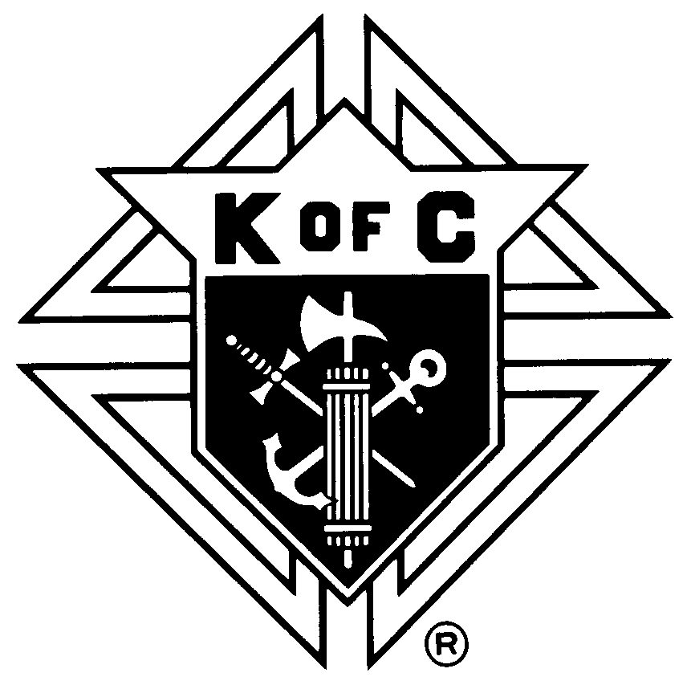
KNIGHTS OF COLUMBUS
DELAWARE STATE COUNCIL

Annual Chaplains & Friars Recognition Night

Monday January 13, 2020 6:00 P.M.

Executive Banquet & Conference Center

205 Executive Dr
Newark, Delaware 19702
Buffet Dinner
$37.50 per person

CUT HERE AND RETURN BELOW PORTION WITH PAYMENT

Reservation Form
Please forward form to:
Frank Strawser
1220 Stinsford Road
Newark, DE 19713
302-593-2362
Cutoff date is January 8, 2020
All information must be completed for each person.
(one name per form please!!!!)

Name: ______________________________________________Phone: _______________________Council #: _______________

Chaplain / Friar? YES NO Circle One

Email address: _____________________________________________

Street:
City: ____________________________________ State: __________ Zip: ____________
Please make checks payable to: Delaware State Council, K of C
Note: No money will be taken at the door.
All reservations must be paid in advance by the cutoff date above!

