Council News
Time to submit your State Service Award Applications. They can be found on the Supreme Website under “forms” (www.kofc.org/forms). You may submit 1 Council Program in each of the 4 Faith In Action Program areas (Community, Faith, Family and Life). Remember to also include them on your SP-7 (Columbian Award) Application, which can also be found on the Supreme Website (www.kofc.org/forms). Deadline for the State Service Awards is April 12th.
We should all be preparing for the 126th Annual RI State Council Convention. It will be here before you know it. May 3rd - 5th are the dates, the Radisson Hotel is the place. If you plan to stay at the hotel, be sure to tell them it is for the Knights of Columbus Convention in order to get the discounted rate. Friday will be the night for Hospitality Suites, Saturday for the Memorial Mass, Ladies Luncheon and State Banquet, Election of Officers and Charity Raffle drawing will be on Sunday morning. Business sessions on Saturday and Sunday.
Remember that the Convention belongs to the local Councils, make sure you are represented.

Additionally, this is the time of year for Councils to prepare for Election of Officers for Fraternal Year 2019-2020.
If you are or have been an Officer, thank you, you may still take part by encouraging “new blood” to step forward. If you are not an Officer or never have served as such, maybe it is time to step up in service. The success of any organization is rooted in a continual flow of new blood and orderly change in leadership. This brings in new ideas and solutions to new challenges, new approaches to old challenges and the courage to meet them all head-on. Orderly change is good, after all, life is inherently changing every day. And we all agree growth (which implies change) is good.

Membership News

Making Councils Stronger

Strong Councils through Accurate and Appropriate Rosters

I begin with an editor’s note/suggestion. I have been in past years a RCIA assistant to my pastor, Fr. Michael Kelley. With the approach of the Easter Vigil, I encourage all to seek new members from amongst the newly Confirmed members of our Church. I have found that it is a good way to harness their new enthusiasm and put it into practice. The support of Fr. Kelley, a 4th Degree Knight was also crucial to my success. So, I urge you to speak with your pastors for permission to speak with the Elect & Candidates about joining the Knights along with joining the Church.

NOW is the time to recruit younger members (middle-age & older members are still okay too)! And, a perfect opportunity to employ the new on-line membership tool www.kofc.org/JoinUs. Once we have them, we then need to ensure they are engaged in our programming and wish to further its aims of Charity, Unity, Fraternity and Patriotism. Without new blood, we will eventually die out, and so will our good works.
One of our strengths as a Fraternal Organization is the generational linkage it allows, connecting grandfathers, fathers, sons & uncles. I’m sure most Councils have some such family/generational story. Below is an example from Newport/Middletown Council.
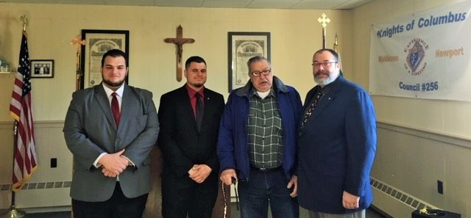
Jim Geer 2nd from the right grandfather, far right Brian Dad and to the left Sons and Grandsons
Following are the upcoming degrees scheduled (so far):
April 3rd – 1st at Newport/Middletown Council @ 6 pm, candidates at 5:30
April 16th – 1st/2nd at Delaney/St. Teresa @ 7 pm, candidates at 6:30
April 17th – 1st at E. Providence Council @ 7 pm, candidates at 6:30
April 24th – 1st at Warwick Council @ 7 pm, candidates at 6:30
April 24th – 1st/2nd at Pope Pius XII Council @ 7 pm, candidates at 6:30
April 25th – 3rd (Knighthood) at Hickey Council @ 7 pm, candidates at 6:30
May 1st – 1st at Newport/Middletown Council @ 6 pm, candidates at 5:30

Degrees and Ceremonials Chairman Bob Lynch would like to see more on the calendar, let’s help him out.
Remember! One member per Council per month!

Message from the State Deputy

My Brother Knights, Families and Friends,
This month we celebrate the Risen Lord and the fulfillment of our faith as Christians which it symbolizes. Through His resurrection our faith as Christians and that faith in Him is alive and powerful. Through His death, Christ saved mankind from the bondage of sin, and He destroyed the hold that death has on all of us; but it is that which gives us the promise of new life, both in this world and the next in His resurrection.
Back to business; hopefully, with three quarters of our Columbian year completed all councils have taken the steps to assess their progress and to determine if they are on track to complete the goals set for themselves nine months ago. Do they feel that they will meet the challenge given to them at our organization meeting in July to make their councils stronger? If not, do not to be discouraged, but resolve to take the steps necessary to enact the necessary changes.
The month of April has a number of activities that you are asked to familiarize yourselves with and show your support for: the KofC Relays, Dillon Council Seder Dinner, St. John Vianney Relic Veneration, Diocesan Men’s’ Conference, and Pastoral Care Dinner. Also, the Book Award/Scholarship Applications due this month. Dates places, and times can be found in the Events of Note section below. Additionally, details on these events can be found by visiting our website or through your District Deputy.
Councils are also reminded to prepare for their attendance at this year’s State Convention the weekend of May 3-4-5, 2019. Council delegate forms have been distributed and must be returned to the State Secretary, David Quinn, prior to the start of the convention. The convention will be held at the Radisson Hotel, Warwick, RI, and room reservations are now being taken. Further details are outlined on our website.
Thank you to Walter Sebastianelli for once again serving as Chairman of the State’s Basketball Free Throw Championship. It had the largest number of participants in recent years.
A special thank you to the brother Knights at Providence College/Friar Council #5787 for hosting our annual Day of Recollection. Their Chaplain, Fr. Bonaventure Chapman, OP, led participants in thought provoking discussions on the meaning and practice of grace.
Finally, on behalf of my wife Vicky and our family, I wish everyone a very Happy and Holy Easter!
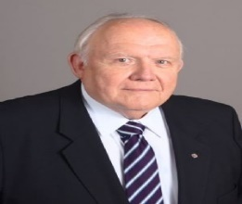

Vivat Jesus!
Mike Dziok

Patriotic (4th) Degree News
From the District Master
Sir Knights and Brothers,
Plans are proceeding for the next exemplification of the 4th degree. I’ve asked Wallace Assembly #1055, led by Faithful Navigator Frank Laiter, to co-chair this event with me and my staff and they have agreed to assist. The date will be May 19, 2019. It will be held at SS John and James Church in West Warwick. The exact time still needs to be pinned down, but it will be sometime around 1 or 2 pm. I am asking councils to promote their 3rd degree members to think seriously about joining the Patriotic Degree and fill out a form #4. I am also asking for Sir Knights throughout the jurisdiction to help me with this exemplification as escorts and color guards. This may be the last double outfit exemplification, i.e. tux, cape & chapeau plus new uniform. So, let’s all get involved and show it before it’s too late.
Also, there will be a Provincial Exemplification in Manchester NH, on Saturday June 15, 2019. Richard McDermott, the NH District Master is asking for Sir Knights from all the New England jurisdictions to send candidates and Color to this event. More information on this will follow as it becomes available.
Vivat Jesus! 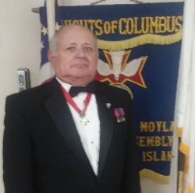
Robert (Bob) Gallant

Programming Activities
All our State sponsored and promoted activities can be used to satisfy requirements of the Columbian Award. Note also that some of our biggest State initiatives began as a local Council activity (e.g. – Operation R.O.V.A.C.). Supporting the causes of other Councils will also get them to reciprocate and support your causes.

- Fraternity begets Unity and together lead to an increase of Charity.
Events of Note
- April 1st to 15th – 40 Days for Life Lenten Campaign continues
- April 4th – Theology on Tap at Uncle Tony’s in Johnston at 6 pm
- April 6th – Family Rosary at E. Providence Council at 10 am
- April 6th - K of C Relays at Mt. Pleasant High School at 9 am
- April 6th - Seder Dinner at Dillon Council at 5 pm
- April 7th – Annual Spring Fashion Show & Ladies Luncheon Bishop Hickey Columbiette Council
- April 14th – Palm Sunday
- April 15th - Book Award/Scholarship Applications due
- April 18th – Holy Thursday
- April19th – Good Friday
- April 20th - Holy Saturday
- April 21st – Easter Sunday – Christ is Risen!
- April 22nd – St. John Vianney Relic at OLP Seminary in Providence
- April 27th - Diocesan Men’s’ Conference at the Cathedral at 8 am
- April 27th – Pastoral Care Dinner
- May 3rd to 5th – State Convention at the Radisson Hotel in Warwick

Check the State Website regularly for details and new listings.

State & Local Happenings
Below are just a few of the many activities held by Councils around the State. Many of our functions build a spirit of Fraternity……

…...while doing good works.

What good is it, my brothers, if someone says he has faith but does not have works? (Jas 2:14)

So also Faith of itself, if it does not have works, is dead. (Jas 2:17)
Life Activities
Sen. Maryellen Goodwin will provide an update on pending legislation concerning life issues and what you can do NOW to stand up for unborn children. All are invited to attend this session on Sunday, April 7th at 10am at St. Patrick Church (in the Gym) 244 Smith St., Providence - ALL ARE WELCOME!
The 8TH Annual Pastoral Care Dinner will be on Saturday, April 27, 2019 at St. Cecilia Church Hall, 1253 Newport Avenue, Pawtucket, RI. Tickets are $30.00 person. Ticket deadline is April 17th. If you are unable to attend but would like to support the effort, you can purchase 50/50 raffle tickets, by sending a self-addressed envelope with a check for the amount of tickets made out to Life & Family Ministry. Tickets are $1.00 each / 6 for $5.00 / 12 for $10.00 mail to Mike Krzywonos, 34 Blackburn Street, Pawtucket, RI 02861-1411 or call Mike at 401-474-2285.
Pro-Life rallies continue against legislation allowing late-term abortions and even disallowing medical treatment for babies who survive such abortion attempts (called NY/VA style abortions) and must continue to be held. Pro-Life supporters must make our presence felt by educating and informing as well as peaceful demonstration.
We also need to rally against Assisted suicide legislation and any other anti-life efforts which our current culture is keen to foist upon us.
The Lenten 40 Days for Life vigil program of the Diocesan Office of Life & Family Ministry in peaceful vigil outside Planned Parenthood through April 15th. This program is heavily supported by Knights from Councils around the State, consider joining for a few hours, days or more as your schedule allows.
Community Activities
The RI Knights of Columbus State Free Throw Championship was held on Sunday, March 24th, 2019 at Bishop Hendricken High School in Warwick.
Boys and girls from across Rhode Island, ages 9 to 14, were named Rhode Island State Champions of the 2019 Knights of Columbus Free Throw Championship. Councils across Rhode Island sponsored the local competition during the past few months and winners from the Councils level moved forward to the State level. All youngsters ages 9 to 14 were eligible to participate. The state competition was held on Sunday, March 24 at Bishop Hendricken High School in Warwick, RI.
Nine-year-old state champions were Guillianna Leitao (Pawtucket) in the girls’ bracket and Thayer Got (Barrington) in the boys’. Molly Thurston (Barrington) was the 10-year-old girls’ state champion and William Bacon (Pawtucket) was the winner of the 10-year-old boys’ division. In the 11- year-olds’ bracket, Trinity Spas (North Smithfield) was the girls’ state champion and Colin McDermott (Barrington) was the boys’ champion. Twelve-year old state winners in the girls’ and boys’ divisions were Lauren Cipriano (Lincoln) and James Mallon (Cumberland). The 13-year-old girls’ division was won by Baily Howell (Westport, MA) and the boys’ by Noah Nichols (Cumberland). Fourteen-year-old state champions were Ahtiana Benway (Lincoln) in the girls’ bracket and Benjamin Reyes (Providence) in the boys’.
Each contestant was allowed 25 free throw attempts in the contests. Ties were settled by successive rounds of five free throws per contestant until a winner emerged. Each of these winners will compete on the international level.
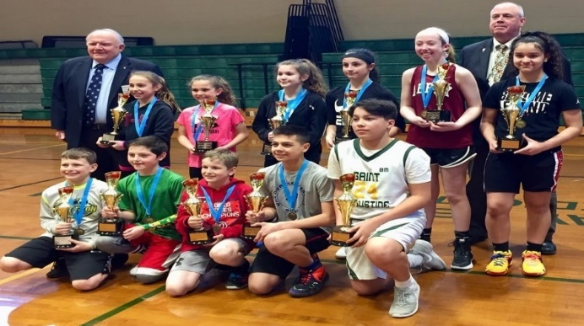
Front Row (left to right): Thayer Got (Barrington), William Bacon (Pawtucket), Colin McDermott (Barrington), Noah Nichols (Cumberland) and Benjamin Reyes (Providence) Middle Row: Guillianna Leitao (Pawtucket), Molly Thurston (Barrington), Trinity Spas (North Smithfield), Lauren Cipriano (Lincoln), Baily Howell (Westport, MA) and Ahtiana Benway (Lincoln) Back Row: State Deputy Michael Dziok and RI State Free Throw Chairman, Walter Sebastianelli, PGK (Note: James Mallon (Cumberland) was absent from picture)
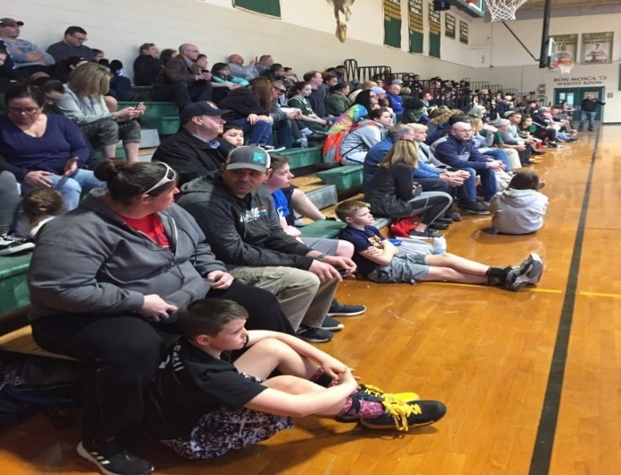
The many supporters of the Free Throw contenders
Thank you to Bishop Hendricken for hosting, Walter Sebastianelli and Family Director Mike Guerra for coordinating on the State level, and all the local coordinators, hosts, families and friends of contestants, and the contestants themselves for participating in this event.

Faith Activities

The annual Day of Recollection was held on March 16th at Dominic Chapel on the Campus of Providence College. Our host for the day was Friar Council, led by GK Sean Tobin. Our presenter was Fr. Bonaventure Chapman, O.P., the Council Chaplain. Our theme was Grace and it was presented in 2 parts: St. Paul and the Angelic Doctor (i.e. St. Thomas Aquinas) & Our Lady and the Seraphic Doctor (i.e. St. Bonaventure). The 30 attendees were thoroughly engaged and spiritually refreshed.
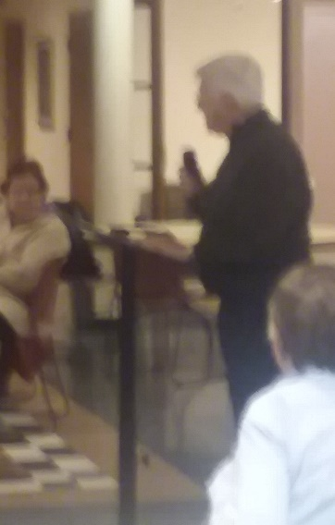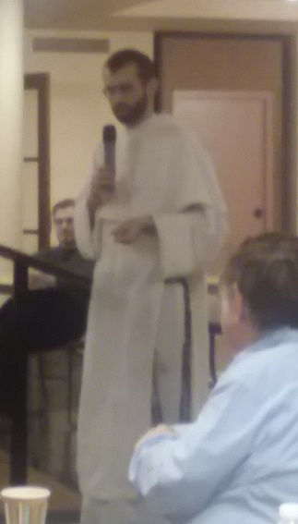
Fr. Joe’s opening remarks (L) and Fr. Bonaventure (R) during his presentation at the Day of Recollection

Each first Saturday of the month, East Providence Council sponsors a Family Rosary at the Council home, 3200 Pawtucket Avenue.
St. Augustine is conducting First Saturday Devotions beginning with the Sacrament of Reconciliation 3:45 PM (continuing until 5:00 PM), the Holy Rosary in song at 4:00 PM, private meditation on the mysteries of the Rosary at 4:30 PM and Mass with Holy Communion beginning at 5:00 PM.

Theology on Tap is an ongoing effort of the Diocesan Office of Young Adult Ministry to energize young adults in their faith. The next session is April 4th at Uncle Tony’s on Putnam Pike in Johnston 6 pm – 8:30 pm. The Topic: What is Faith?

In our ongoing prayer efforts for the increase of Vocations, please be mindful of the events on the flyer below.

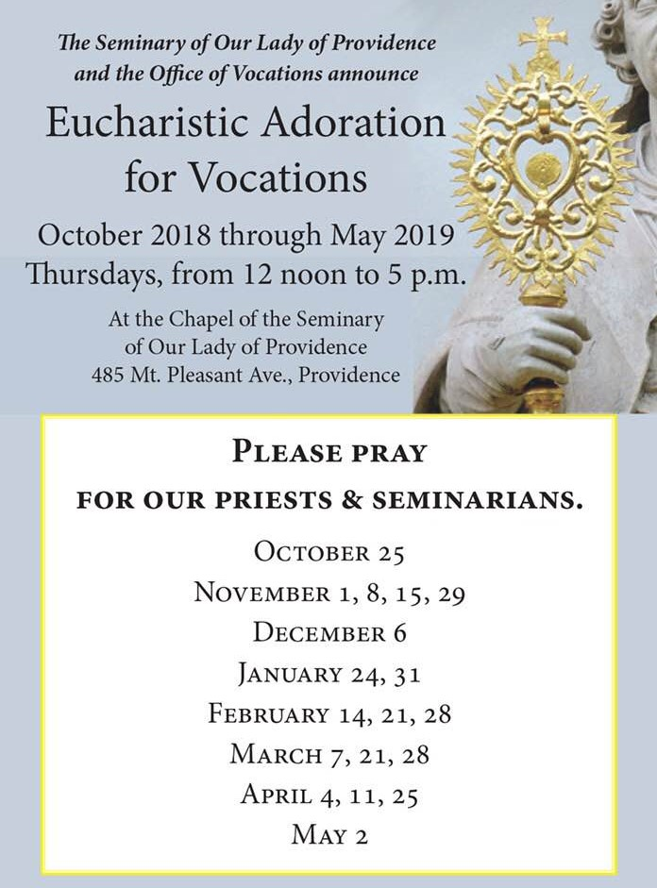

Family Activities
The Youth of the Year has been chosen from amongst the submissions and will be announced at the State Convention Banquet on Saturday May 4th.

Want to help benefit Catholic Education Scholarships? Of course, you do! How? It’s time to start putting together your golf foursomes. The Annual State Charity Golf Tournament (the proceeds benefit the aforementioned scholarships) has been booked for Saturday, June 15th at Swansea Country Club (299 Market St., Swansea). There will be a 12:45 pm Shotgun Start. Cost for the day is $125 per person and includes a BBQ lunch on site. There raffles, prizes and, of course, The Championship Trophy. For those of you who don’t play (or shoot a nice 72 on the front nine like your editor) but would like to contribute, there are sponsorship opportunities. Contact PJ Shea 401-480-2365 or Phil Shea 401-585-8528 or KofCGolfRI@gmail.com for information or with questions.

Columbiette Activities
The Columbiettes of Bishop Hickey Council #3623 will hold their Annual Spring Fashion Show & Ladies Luncheon @ St. Brendan’s Church in Riverside on April 7th at 1 pm. Fashions by Annie’s Unique Boutique. Cost is $10. Contact Jean at 401-497-0515.
Fraternal Training and Communication
Training
There are many training opportunities throughout the year (see the Supreme Website – www.kofc.org ), they are open to any Brother Knight who may be interested. You can register from the Home Page of the supreme website: go to Members, Resources & then the Fraternal Training tab. You must register to participate, but once registered, you do not have to view it live. Rather, you can view it later at a time of your convenience. The next scheduled webinar is on April 23rd at 8:30 pm and is titled “Your Council’s Charity Story is Attractive”.
Additionally, the State Council has a Training Officer available to assist with any topic. PSD FM Steve Ciolfi is here to help. You can reach him at stevec618@aol.com.

State Website
Check out the State Website at www.kofcri.org . It is connected to UKnight Interactive (kofcknights.org) and allows connection to any local Council website that is also a part of the UKnight family. There are also links to other sites of interest such as Fathers for Good, the Supreme Council et alia.
State Newsletter
News items for the newsletter can be sent to me at rikofcnewsletter@gmail.com, through your DD, who will forward it to me, or the various program Directors. I also welcome photos from the event itself.
As you know, I have shared local Council newsletters with you as they are shared with me. This month I submit to you the newsletter of St. Augustine Council, which you can find attached to the same email with which I have sent this newsletter. Fouad Faraj-Musleh is the new editor.
State Meeting
Remember! these meetings allow interaction between local Councils, and allow information to be exchanged between the local and State Councils (in both directions). Each Council should ensure that it is represented at these meetings.
The next State Meeting will be the State Convention (I know we don’t usually think of this as a State Meeting, but realistically it is indeed such) to be held May 3 - 5 at the Radisson Hotel in Warwick. This is the most important State Meeting of the year, please send Council representatives to the Business portion at minimum. As noted above, this is Your Convention, the State Council would not exist without its local Councils.

Fraternal Concern
Brothers, as noted previously, our membership is older, with an average age of 64. Implicit in that average is the fact that we have many older Brothers. These Brothers often are unable to regularly attend meetings and functions. This can lead to Councils losing track of them and, unfortunately, should they pass away we fail to recognize their significance and membership in our Order. I am asking that the word be spread among your membership and families to be vigilant to the passing of a Council member or Council family member and relay the information to the Grand Knight. In my home Council, I have designated a member to scan the newspaper obituaries. However, with fewer people utilizing the newspaper obits we must now add word of mouth or social media methods of communication.
Regardless, we must be informed to properly Honor the Dead.

Prayers Requested
Prayers are requested for the repose of the soul of:
Francis Sisko, father of Fr. Mike Sisko, Pastor of St. John Paul II & Chaplain of its K of C Council
Robert Kenney, father of Msgr. Albert Kenney, Diocesan Vicar General
Theresa Masterson, grandmother of GK Jay Masterson (St. Francis Council)
Reverend Gerald W. Hussey, Pastor Emeritus of St. Catherine of Siena, Little Compton, and St. Madeleine Sophie, Tiverton
and God’s comfort to their families.
Prayers are also requested for Bishop Louis Gelineau, Fr. Dennis Reardon, Fr. Robert Bailey, Phil Shea Jr., Patricia Moran (grandmother of Membership Director PJ Shea) Nancy Forest (wife of PGK Richard Forest), Pat Logan (wife of PGK Greg Logan), Cheryl Tedeschi (wife of FDD Anthony Tedeschi), PSD/FVSM Sav Giusti, FDD Ray Riel, PFN Rick Regan, Roger Depot, Executive Secretary Mike Krzywonos, PGK PFN Ernie Pennine, PGK/PFN Walter Jalbert, DD Bud Garceau, PGK/PFN Stanley Eason (Woon. Council/ Moylan Assembly), GK Jerry Marra, Ellen and PSD Normand Charpentier, Pat DeMello (wife of recently deceased FDD Bob DeMello), Bob Jackson (St. Francis Council), Mike Magill, DD Alan Lamake, David Riendeau (John Paul II Council), DD Dave Lucas, and FDD George Plante as they each deal with various health concerns.
I am sure I am missing others, and for that I apologize. Please feel free to add them to this list of those we pray for and remember.

[to have someone mentioned, contact me @ rikofcnewsletter@gmail.com or ask the state to add to the prayer list on the website. Conversely, should anyone wish to be removed from the list, please let me know (I wish to be sensitive to their wishes and sensibilities)].

Contact Information
Officers
State Deputy Michael Dziok mdziok1067@aol.com
State Chaplain Fr. Joe Paquette JoePaquette1@gmail.com
State Secretary Dave Quinn davequinn.rikofc@aol.com
State Treasurer Dave Bebyn dbebyn@beconsulting.biz
State Advocate Joe Carrignan joe.carrignan@outlook.com
State Warden Eric Batista ebkofc@gmail.com
Immediate Past State Deputy Mike Benson MBenson.rikofc@gmail.com
Patriotic Degree
District Master Bob Gallant – bobgal664@gmail.com
District Marshall John Tougas – jtougassr@gmail.com
District Marshall Warren Rensehausen - wrensehausen@hotmail.com
Executive Secretary Ron Ross - 1970cheron@gmail.com

Staff et al.
Exec. Secretary Mike Krzywonos mikrzywonos@gmail.com
General Agent Scott Eastwood scott.eastwood@kofc.org
State Webmaster John Tougas jtougassr@gmail.com
State Newsletter Editor Jack Tracy rikofcnewsletter@gmail.com or jklmc.tracy@att.net for the Charity Raffle
District Deputies
District 1 Al Nunes – al.nunes@trimarkusa.com
District 2 Jerry Scannell – paulgscannell@gmail.com
District 3 Bob Moniz – rjm51@cox.net
District 4 Mark Paul – mpaul@astromed.com
District 5 Victor Silva – vmsilva58@gmail.com
District 6 Mike Colvin – mikegcolvin@gmail.com
District 7 Matt Belair – mattbkofc@gmail.com
District 8 John Kay – jkay4021@aol.com
District 9 Paul Saunders – psaund1229@aol.com
District 10 Dave Lucas – ldaviddance@aol.com
District 11 Bud Garceau – gene.garceau@gmail.com
District 12 Alan Lamake – allamake@aol.com
Directors
Membership Director PJ Shea – sheapj@yahoo.com
Degree & Ceremonial Director Bob Lynch rlynch1@cox.net
Program Director Jeff Gaulin jagaulin@verizon.net
Church Director Mike DeAngelis deangelis36@msn.com
Community Director Steve Perry brady12qb@verizon.net
Family Director Mike Guerra mikegonemad@gmail.com
Life Director Mike Krzywonos mikrzywonos@gmail.com
Contact information of subcommittee chairmen and other State Staff can be found on the State website www.kofcri.org
Remember, these men are here to help you and your Council. Don’t be afraid to contact them for help or with any questions you may have.
Vivat Jesus!
