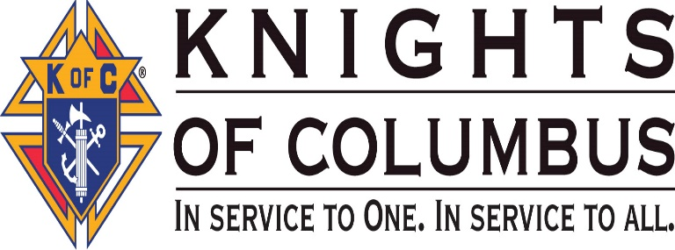
Notice of State Meeting:

Worthy Brothers all,
The Rhode Island State Council State meeting, will be held on Friday, March 27, 2018 at All Saints Parish, home of Woonsocket Council #113, 323 Rathburn Street, Woonsocket, RI. Start time 730pm. All Brother Knights are encouraged to attend. The dress code is business. Some topics to be discussed will be:
- 125TH RI State Convention on April 27, 28 & 29, 2018
- And more!

Michael Benson Michael Dziok
State Deputy State Secretary

