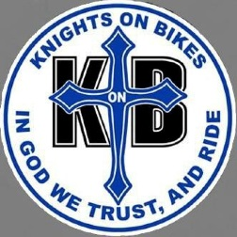
Oklahoma Knights on Bikes

The Oklahoma Knights on Bikes (KonBs) is an International organization that serves as the Motorcycle Ministry Arm (Auxiliary) and Catholic Evangelistic outreach of the Oklahoma Knights of Columbus. It was founded in 2005 in Ft. Worth, Texas. Chapters are located throughout most of the United States and are also found in Mexico, Canada, and the Philippine Islands.
The KonBs are a strong supporter of the Center of Family Love in Okarche, OK. Through various events, such as “Fill The Helmets” and the “Love Run”, the KonBs are responding to the call of the Oklahoma Knights of Columbus State Council to raise additional funds for the Center of Family Love.

Currently, there are over 70 members statewide in Oklahoma. Below are the various leadership positions for 2016-2017:

State President: Larry Morgan, Council 1018
State Chaplain: Fr. Jim Caldwell, Pastor of St. Monica (Tulsa)
State Vice President: Mark Cearley, Council 4721
President, OKC Diocese: Troy Ogden, Council 6478
President, Tulsa Diocese: Russ Harrison, Council 13313

