Knights of Columbus Tuuri Agency is pleased to introduce

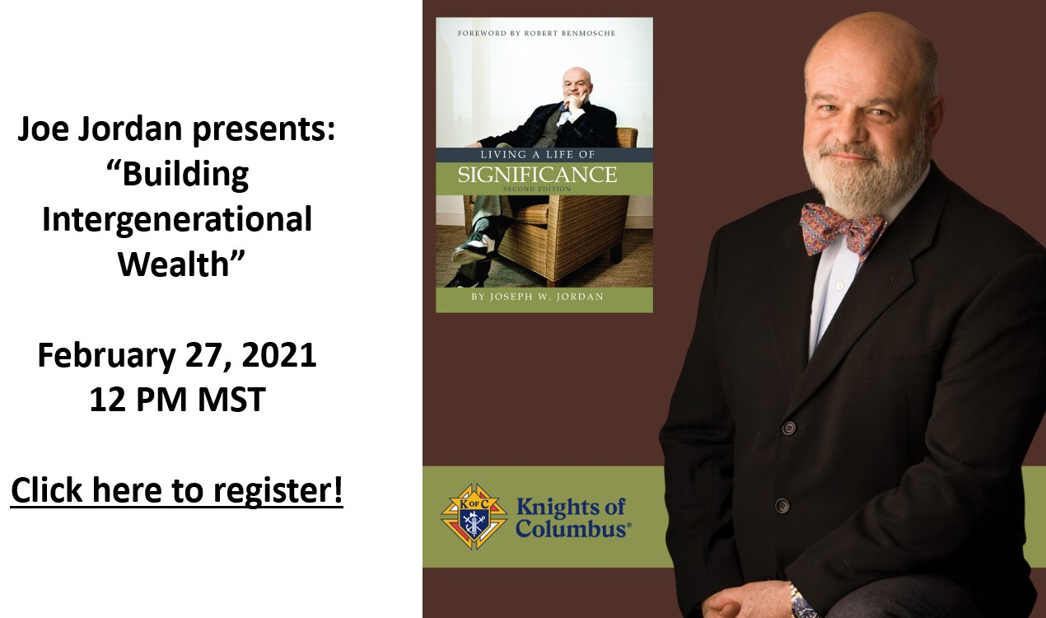

Join us for an informative presentation by inspirational speaker and behavioral finance expert Joe Jordan. Joe will discuss “Building Intergenerational Wealth,” including how to plan for your financial future and a secure retirement. Joe believes in the mission of the Knights to protect families by providing economic security and stability. Only by helping others can we truly “Live a Significant Life.” Here are some of the topics Joe will cover:

- The importance of “Living a Significant Life” that goes beyond merely accumulating wealth
- Eight steps to financial security
- Capital markets explained in 5 minutes
- The importance of having a plan and a partner
- Why long-term care doesn’t have to be a financial nightmare
- How to turn hard earned assets into reliable retirement income
- Protecting your loved ones with life insurance
- Why patience pays when claiming Social Security
- Six risks to a secure retirement and how you can insure against them

His talk will give you new insights into your financial affairs without losing sight of your faith and values. Click here to see Joe’s special message to the Knights. We look forward to Joe’s presentation on February 27 at 11 Pacific Time. Click here to register now!

About Joe Jordan

Joe Jordan, inspirational speaker and behavioral finance expert, is the author of the award-winning book Living a Life of Significance. His book is a call to action for financial professionals to think beyond just how much money they can make and to focus on the positive impact they have on others.

Joe has worked in financial planning and insurance for 46 years, and his book and presentations are designed to instill Christian values into the financial service business.

Joe is a Catholic, a Knight, and a member of Legatus, a Catholic CEO organization.

For three consecutive years, he has been honored by Irish America magazine as one of the "Top 50 Irish Americans on Wall Street."

He was inducted into the Fordham Football Hall of Fame and has played rugby for the New York Athletic Club for 30 years.

