Financial Secretaries Resource Guide

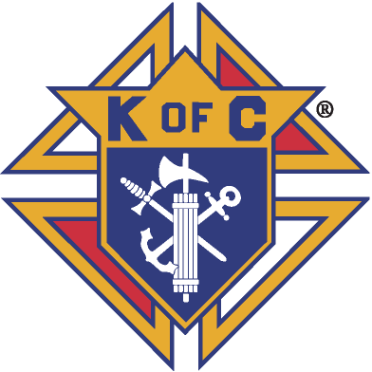
April 27, 2018
Dear Brother Knights,

This Financial Secretaries Resource Guide is designed to help you be an effective Financial Secretary. The information in this document also serves as a resource for Grand Knights, Treasurers, Trustees, as well as other council officers and members. In addition, the Financial Secretaries Resource Guide contains additional resources such as illustrations, graphics, screen shots, and links to various state and Supreme Council forms.

There are also sixty-two Frequently Asked Questions located in the back of the Financial Secretaries Resource Guide. This information covers Account Keeping, Bonding, Council Financial Team, Council Statement, Data Change, Duties, Financial Secretary Evaluation, Honorary Membership, Insurance, Membership Cards, Member Management, Membership Numbers, Membership Rosters, Membership Transactions, Officers Online - Expert Help and Training, Online Membership and Tax Form 990N questions. Please review these questions to expand your knowledge of the duties of the Financial Secretary and the organizational structure of the Knights of Columbus.

I also encourage you to take the Financial Secretary’s training course offered by the Supreme Council. This training course can be accessed at the Open Enrollment Micro-Site - www.kofc.org/trainingmicrosite

Additionally, a training site can be accessed by clicking on the Sign In – Officers Training link located in the upper right-hand corner on the “Expert Help” site in Member Management. Click on the Officers Online – Expert Help & Training for more information.

If you are a new or recently appointed Financial Secretary, please click on the following Resource Topics Tabs
(1) Account Keeping, (2) Officers Online – Expert Help & Training and (3) Billing Timeline for Dues Collection, to access information that will be especially helpful in getting started. Additional Topic Tabs are available on the next page.

You can also click on the link, http://www.kofc.org/en/forms/leadership/financial-secretary-flyer10238.pdf to access the Summary of Financial Secretary’s Responsibilities. In addition, you can click on the link to access the Financial Secretary’s Guide http://www.kofc.org/un/en/resources/officers/fshandbook.pdf. These publications contain a description of a Financial Secretary’s ongoing duties, as well as the various deadlines you must meet each month.

You can also click on the link below to access Knights of Columbus Leader Resources, which is a practical guide for District Deputies, Grand Knights and Financial Secretaries. The Financial Secretary information begins on page 34. Please utilize this valuable resource material as you carry out the duties of your office.
http://www.kofc.org/en/resources/officers/officers.pdf

I served as a District Deputy, a Grand Knight as well as a Financial Secretary for two different councils. I look forward in working with all of you as we share our experiences and expertise with one other. This is a living document.

Please feel free to contact me at any time if we need to make any corrections, changes or additions to this Financial Secretary Resource Guide. My contact information is listed below and in the State Directory.

Good luck.

Dr. Ronald Larchick
Oklahoma State Council Knights of Columbus
State Training Director

CONTACT INFORMATION
e-mail rllarchick@gmail.com
Cell 405-819-9153
Text 405-923-4580
Home 405-799-4071

Resource Topics Tabs
(Click on the links below to view helpful information)

Account Keeping  Accounting System Checks and Balances  Admission Committee and Membership Admission Procedures  Audit  Back Dues Collection  Billing Timeline for Dues Collection  Board of Trustees – Duties  Bonding  Center of Family Love (Love Challenge)  Charitable Fundraiser Guidelines  Charter Constitution and Laws  Constitutional Roll  Council Budget  Council Financial Team  Council Liability Insurance  Council Statement  Data Change  Disability – Relief from Payment  Dues Adjustment Chart  Duties  Family of the Month Program  Financial Secretary’s Duties for an Admission Degree (1st Degree)  Financial Secretary’s Duties for the Formation & Knighthood Degrees – (2nd & 3rd Degrees)  Financial Secretary Evaluation  Forms and Reports Calendar  Frequently Asked Questions  Grand Knight - Financial Duties  Honorary Membership  How to Notify Supreme | Institution of Payment  Insurance  Intellectual Disabilities – a.k.a. Tootsie Roll Drive  Issuing Council Checks  Life Travel Card  Member Management  Membership Information – Oklahoma State Council  Membership Cards  Membership Numbers  Membership Transactions  Membership Rosters  Officers Online – Expert Help & Training  Oklahoma State Council Forms  Officers’ Desk Reference  Order on Treasurer  Ordering Supplies  Privacy of Membership and Financial Information  Records Management  Report of Officer Elections  Safe Environment Training  Service Program Personnel Report  Star Council Award  State Per Capita  Supreme Per Capita  Survey of Fraternal Activity  Suspension of Council  Tax Form 990N  Treasurer Duties

Account Keeping

The information in this section covers many wide-ranging topics that will assist you in your work as a Financial Secretary.

You will be able to access screen shots of Illustrations highlighted in yellow and return to this section when finished.

The Billing Procedures duties of the Financial Secretary as set forth in Section 139 of the Charter Constitution and Laws of the Knights of Columbus http://www.kofc.org/en/forms/leadership/charter-const-laws30.pdf stipulate that the Financial Secretary shall collect and receive all moneys accruing to the council from members and other sources, that he shall keep an account of the indebtedness of each member of the council and the amount received from each member of the council and that he shall pay over to the Treasurer of his council all moneys received by him from all sources. To assist him in complying with these duties, the Supreme Council has developed and makes available for local council use a computer-based system of record and account keeping.

Using the Member Billing Application

The Member Billing Application – located in Officers Online, the Sign In area of www.kofc.org – which works in conjunction with the Member Management application to allow councils to manage the financial transactions for their council.

Initial Set Up for First Time Users

If you are just starting to use Member Billing, there are a few steps that are required prior to generating as assessment. You must set up the following items:

- Billing Information

The billing frequency needs to be established. Member Billing allows you to assess dues to members annually or semi-annually only. If your council has quarterly payors, you can inform them that they can continue to pay quarterly but will be billed annually or semiannually, as is the council preference.

Additionally, the billing schedule must be selected as calendar or fraternal year. Also, the billing remittance address needs to be selected – either the council’s mailing address or meeting address, or the Financial Secretary’s mailing address.

- Class List

This screen is where the amount of the council’s dues can be entered. Note that the amount of annual dues for honorary members is based on the sum of state and Supreme Council per capita taxes and other levies. The annual dues for honorary life members is specified in the Charter Constitution and Laws of the Knights of Columbus and cannot be updated in Member Billing.

Sub Class – Council defined sub classes can be created for members for which the council wishes to reduce the dues amount. For example: a council waives or reduces dues for students. A sub class of students can be added, along with the annual rate of the reduced dues. Once established, members associated with a sub class will need to be assigned to the sub class on the member’s “Billing Information” screen, located under the Member Information section.

- Reasons for Assessments

This is required if the council plans to assess members any special or miscellaneous assessments. Reason for Assessments can be added on the “Event/Assessments” screen under the council’s billing Information section.

Setting up the member's billing information located in the Member Information section includes the following items: (Illustration # 1)

- Member Class

Displays the member as a regular, honorary, or honorary life member.

- Sub Class

Members may be assigned as part of a sub class and eligible for reduced dues (military, students, etc.)

- Disability

Members that are on disability and noted “Yes” on the Members Billing Information screen will not be assessed dues. Nothing else is required to ensure that they are not assessed.

- Do Not Assess

This provides the ability to not assess dues for members who may have a special circumstance, such as financial hardship, where the council decides not to assess dues for a period. Note that honorary life or disabled members are not included in the dues assessment process, so this option does not need to be selected for these members.

- Do Not Send Bill

This provides the option of not sending a billing notice to specified members for any reason. Note that the member will still be assessed, but a notice will not be generated.

- Delivery Preference

This identifies the preferred method by which the member wished to receive his billing notice – mail, email or both.

- Language Preference

This allows a billing notice to be generated in a different language.

- Billing Address Information

This section allows the Financial Secretary to update a member’s contact information including: Address, phone number, fax number and email address. These changes will also be made in Member Management as well as alert Membership Records at the Supreme Council Office.

Prior to generating the initial dues assessment, if there are members with an outstanding balance for previous billing periods, these member records should be updated in the Member Ledger.

- Billing Status

When a dues assessment is processed from the “Pending Assessment” screen, the billing status for all members receiving this assessment will be charged to First Notice. Note that honorary life members do not receive an assessment, and their billing status can be manually updated to “Dues are Current. Additionally, former members that are listed in Member Management/Member Billing can be manually changed to Prior or Deceased status. (Illustration # 2)

- Adjustments

Adjustments – The Adjustment section on the bottom of the Member Ledger screen can be used to generate a charge adjustment for members with an outstanding balance. (Illustration # 3) Separate adjustments should be added if a member owes money for dues and other assessments (i.e., initiation fees, dues, special assessments, etc.).

If a member has paid dues or other assessments for future periods, a credit adjustment should be added. Payment of dues should not be recorded here, but through the Dues Collection Tool found under the Receipts section of the Council ledger. (This is the same process as assessing new members for dues or initiation fees after they have been recorded at the Supreme Council Headquarters and added to Member Management/Member Billing.)

Billing Members
A dues assessment can be generated for all billable members on the Enter Dues Assessment screen by clicking on Assessments under the Council Ledger section. (Illustration # 4)

- Billing Cycle

Dues can be billed for the calendar year (Jan to Dec) or the fraternal year (Jul to Jun). (Note that the default for the billing period is predetermined by the billing frequency, which is selected in the Billing Setup Section.)

- As of Date

As of Date — All bills have a date that indicates how much is owed at the time the dues were assessed. Dues can be assessed in Member Billing as early as 60 days prior to the billing period. However, the “As of Date” cannot be set more than 15 days prior to the billing period. The date used for the “As of Date” when generating a dues assessment also should be used for any special or miscellaneous assessments.

- Assess Dues Button

This will place the dues assessment in a pending status, which can be processed on the Pending Assessments screen. All special or miscellaneous assessments should be assessed on the “Assess Other” screen before processing the dues assessment.

A special or miscellaneous assessment can be generated for selected members using the Assess Other screen under Assessments in the Council Ledger section.

- Charge To

Charge To — This specifies who will be assessed the additional charge and is selected by member type. (“All Billable” will assess all regular and honorary members; “All Members” will assess all regular, honorary and honorary life members; “Honorary” will assess only honorary members; and “Honorary Life” will assess only honorary life members).

- Voluntary or Mandatory

If an assessment is a voluntary assessment, a notation will display on the member’s bill showing that this assessment is voluntary and payment is optional. Voluntary assessments require a valid “Through Date”. A valid “Through Date” should be selected well in advance of the last day of the billing cycle (i.e. if using a calendar year billing cycle, select a date of June 1 — well in advance of Dec. 31). After this date, you have the ability to initiate a process that will generate a credit transaction for all members that did not pay the voluntary assessment. Mandatory assessments will remain on the Member Ledger until the member pays the assessment or the transaction is voided on the Member Ledger.

- Reason for Assessment

Reason for Assessment - This is a required field, and if the “Reason for Assessment” does not appear in the drop-down list, it can be added on the “Event/Reason” screen under the Billing Information section. Note: there is a link to this section on the bottom of the “Assess Other” screen.

- Assess Other button

Assess Other — This will place any special and miscellaneous assessments in a pending status, which can be processed on the “Pending Assessments” screen. All special or miscellaneous assessments should be assessed on the “Assess Other” screen before processing the dues assessment.

All pending assessments can be posted to the Member Ledger from the “Pending Assessment” screen. When the “Process Assessment” is clicked, the billing status for all members will change to “First Notice.”

Generating Notices

Once the pending assessments are processed, the First Notice can be generated from the “Notices” section of the Print Center in Member Billing. (Illustration # 5) (If the respective officers’ names or telephone numbers do not display on the Notice, the data can be added on the “Council/Assembly Officers - Current Year” screen in Member Management.)

PLEASE NOTE: If your council bills on a calendar year process, the FIRST NOTICE will be sent on December 15. This date begins the billing cycle.

PLEASE NOTE: If your council bills on a fraternal year process, the FIRST NOTICE will be sent on June 15. This date begins the billing cycle.

You can also click on the link, http://www.kofc.org/en/forms/leadership/financial-secretary-flyer10238.pdf to access the Summary of Financial Secretary’s Responsibilities for more billing information.

Notices can be sent via email, or printed and mailed, based on delivery preferences on the member’s Billing Information screen. There is also an option to generate a file copy of all Notices to members.

Member Billing also provides the ability to email an individual Notice to members who have been added to Member Management/Member Billing. Once the member delivery preference is set to email or both, an “Email Notice” icon will appear on the Member Ledger or member’s Billing Information screens.

Thirty days after the “As of” date, you can update all members currently in the “First Notice” status to “Second Notice” status by using the “Update Status” screen under the Assessment section of the Council Ledger. (Illustration # 6) Notices can be sent via email, or printed and mailed, based on the delivery preferences on the Member Billing Information screen. Second Notices can also be saved electronically.

Thirty days after the “As of” date of the Second Notice status, the Financial Secretary will provide the contact information and amount due from each member in arrears to the retention committee for personal follow up.

If directed by the Grand Knight, you can update all members currently in the “Second Notice” status to “Knight Alert” status by using the “Update Status” screen under the Assessment section of the Council Ledger. (Illustration # 6) The Knight Alert letter being sent to the member explains how his membership is in danger of being forfeited as a result of unpaid dues. The Knight Alert letters cannot be sent electronically because they require the signatures of the Grand Knight and Trustees.

Fifteen days after the “As of” date of the “Knight Alert” status, all members currently in “Knight Alert” status can be updated to “Intent to Retain” status by using the “Update Status” screen under the Assessment section of the Council Ledger. (Illustration # 6) A Notice of Intent to Retain can be generated in the Billing section of the Print Center, informing the member that his delinquency has put his membership in jeopardy. Copies of the letter must be sent to the Supreme Council Headquarters, the state deputy, and the district deputy. Individuals who have been assessed for the current billing period, but have become former members, need to have any outstanding balances and their billing status manually updated on the “Member Ledger” screens. If the billing status has not been updated, these members will continue to appear when the next notice is generated.

Processing Payments from Members

Under the “Receipt” section of the Council Ledger, there is a “Dues Collection Tool” to record members’ payments. The “Dues Collection Tool” is used if the member pays his outstanding balance in full. (Illustration # 7)

If a member does not pay the full amount or includes a donation to the council or special fund, the payment should be recorded on the “Enter Receipt” screen to ensure that the proper accounts/subaccounts are recorded properly. If his payment includes money for a special or miscellaneous assessment, a “Reason for Assessment” must be entered in the “Event” field.

Once the “Save” button is clicked on the “Dues Collection Tool” screen or the “Enter Receipt” screen, this will place the transaction in “pending” status. Pending transactions can be processed on the “Pending Receipt” screen.

A Report of Receipts is available under the Treasurer Reports in the Print Center of Member Billing. (Illustrations # 9 and 10) There are four reports available: two for pending receipts and two for posted receipts. (Posted receipt reports will display signature lines for the financial secretary and treasurer, which serve as a record that the treasurer received these moneys. If the treasurer’s name does not display on this report, add his data on the “Council Officers — Current Year” screen in Member Management.)

Processing Money from Other Sources

Section 139.1 of the Charter Constitution and Laws of the Knights of Columbus http://www.kofc.org/en/forms/leadership/charter-const-laws30.pdf specifies that the Financial Secretary shall collect all moneys accruing to the council from members and other sources. These moneys can be recorded in Member Billing using the “Enter Receipt” screen under the Council Ledger. (Illustration # 8)

Note: Member or Payor - Prior to entering the receipt information, you must search for a member or a payor.

A payor is an individual or entity that is not a member of the council (i.e., the Supreme Council or state council). A payor can be added to Member Billing on the “Add a Payee/Payor” screen under Billing Information.

Once a search has been conducted, the results will appear in the “Search Results” box to the right. Click on the desired member or payor so that it is highlighted in a blue banner. Click the “Select” button to populate the date and member/payor in the “Enter Receipt” section on the bottom of the screen. Continue to enter the remaining information.

Once the “Save” button is clicked, the transaction is placed in “Pending” status. Pending transactions can be processed on the “Pending Receipts” screen.

Generating Membership Cards

Membership cards can be generated for members using the Membership Card Section of the Print Center in Member Billing. We suggest printing membership cards using the by Member Type feature, thereby having these cards ready for presentation when the member submits his payment for dues.

Membership Card Stock paper (#4817) for Member Billing can be ordered from the Supreme Council Supply Department. Note that cards come 8 to a sheet with 25 sheets to a package for a total of 200 cards.

There are three options in Member Billing for printing membership cards:

- By member type, which can be classified as: All Billable, All Members, Regular, Honorary, Honorary Life or members on Disability.

- By all members whose dues became current between specified dates.

- By using the Membership Card Template for a small group of members or for new members who have not been added to Member Billing.

Processing Vouchers for Payment

After a bill has been properly approved for payment, the Financial Secretary must initiate the procedure for issuance of a check by the Treasurer, which can be accomplished under the Vouchers section of the Council Ledger. (Illustration # 11)

Member or Payee – Prior to entering the voucher information, you must search for a member or a payee.

Note: A payee is an individual or entity that is not a member of the council (i.e., the Supreme Council or state council). A payee can be added to Member Billing on the Add a Payee/Payor screen under Billing Information.

Once a search has been conducted, the results will appear in the Search Results box to the right. (Illustration # 11) Click on the desired member or payee so that it is highlighted in a blue banner. Click on the Select Button to populate the date and member/payee in the Enter Vouchers section on the bottom of the screen.

Once the Save button is clicked on the Enter Vouchers screen, the transaction is placed in pending status. Pending transactions can be processed on the Pending Vouchers screen.

A Report of Vouchers is available under the Treasurer Reports in the Print Center of Member Billing. (Illustration # 12) There are four reports available: two for pending vouchers and two for posted vouchers. Note that the Report of Vouchers will display signature lines for the grand knight, financial secretary and treasurer, which serve as a record that the treasurer is authorized to write a check. If the treasurer’s name does not display on this report, add his data on the “Council Officers — Current Year” screen in Member Management.)

Note: A payee is an individual or entity that is not a member of the council (i.e., the Supreme Council or state council). A payee can be added to Member Billing on the Add a Payee/Payor screen under Billing Information.

Click to Return to Resource Topics Table

Accounting System Checks and Balances

Regardless of the accounting system used by the council, the Laws and Rules provide for the Financial Secretary to receive all moneys and for the Treasurer to disburse all council funds. For this reason, the Financial Secretary cannot be a signatory on council checks and accounts. Doing so would violate the Laws by allowing the Financial Secretary to participate in the disbursement.

Click to Return to Resource Topics Table

Admission Committee and Membership Admission Procedures

The guidelines detail the duties of the Grand Knight In relation to appointment of an Admission Committee, the procedures to be utilized by the committee in its interviews with prospective members and the method to follow when presenting the member’s application to the council for approval.

The Board of Directors, in interpreting the Charter Constitution and Laws of the Knights of Columbus (Sections 108-109, 112-113), http://www.kofc.org/en/forms/leadership/charter-const-laws30.pdf has prescribed the following procedure for all councils of the Order.

Admission Committee
SEC. 108. The Grand Knight shall appoint an Admission Committee of seven members. Within five days after the presentation to him of the application, the Grand Knight shall refer the application to the Admission Committee and thereupon said Committee shall notify the applicant to appear before it for examination as to his qualifications for membership. If five members of the Committee shall file a written report withholding endorsement because the applicant is not a practical Catholic, said applicant shall be deemed rejected. Otherwise the recommendations of the Admission Committee shall be evidenced by the certificate of the Chairman of the Committee on a form to be prescribed by the Board of Directors. In the event of the failure or neglect of the Admission Committee to make report within ten days after an application has been referred to it, the Grand Knight shall discharge the said Committee and shall forthwith present said application to the council for action.

Click on the link below to proceed to Section 109 on pages 46-47 and Sections 112-113 on pages 47-48 Charter Constitution and Laws of the Knights of Columbus
http://www.kofc.org/en/forms/leadership/charter-const-laws30.pdf

Click to Return to Resource Topics Table

Audit

Please review Sections 41 and 145 of the Charter Constitution and Laws of the Knights of Columbus that requires the Grand Knight and Trustees to audit the accounts of the Financial Secretary and Treasurer at least every six months and in January and July.

Click on the link below to proceed to Sections 41 and 145 Charter Constitution and Laws of the Knights of Columbus.

http://www.kofc.org/en/forms/leadership/charter-const-laws30.pdf

You can access additional information concerning the council audit by clicking on the link below to open the Knights of Columbus Leader Resources. This document is a practical guide for District Deputies, Grand Knights and Financial Secretaries. The different sections of the council audit are described in the Grand Knight section on pages sixteen, seventeen, and eighteen of the document.

http://www.kofc.org/en/resources/officers/officers.pdf

The audit report should be sent to their District Deputy, State Deputy and the Supreme Secretary on forms (see item #1295 see below) approved by the Board of Directors and furnished by the Supreme Council. Under no circumstances should either the Financial Secretary or Treasurer prepare the audits. But each should be readily available to the Trustees to answer questions regarding the records. The trustees are charged with this duty, and in accepting office they are accepting the responsibilities the office entails.

Audits for the period from January 1 through June 30 are due on August 15.

Audits for the period from July 1 to December 31 are due on February 15.

Go to http://www.kofc.org/en/members/resources/forms/council.html to access Audit form item #1295

Click to Return to Resource Topics Table

Back Dues Collection

A council may only bill a member for the dues amount for the current billing cycle. For example, let’s say your annual dues are $30.00 and a member owes $120.00 for non-payment of dues over the past four years.

The total amount of dues owed by the member appears to be $150.00 (four years of @120.00 plus $30.00 for the current year).

However, the collection of dues owed from previous fraternal years is prohibited. The member can only be billed for the current annual dues amount of $30.00.

Click to Return to Resource Topics Table

Billing Timeline for Dues Collection

The Financial Secretary shall collect and receive all moneys due the council and all funds obtained from any source Section 139 of the Charter Constitution and Laws of the Knights of Columbus http://www.kofc.org/en/forms/leadership/charter-const-laws30.pdf

The timeline for the billing procedures for the collection of council dues includes the following:
The Financial Secretary will mail the Membership Bill - First Notice Form #423 15 days prior to the billing period.

PLEASE NOTE: If your council bills on a calendar year process, the FIRST NOTICE will be sent on
December 15. This date begins the billing cycle.

(PLEASE NOTE: If your council bills on a fraternal year process, the FIRST NOTICE will be sent on June 15. This date begins the billing cycle.

You can also click on the link, http://www.kofc.org/en/forms/leadership/financial-secretary-flyer10238.pdf
to access the Summary of Financial Secretary’s Responsibilities for more billing information.

If payment is not received in 30 days, the Financial Secretary will mail the Membership Bill — Second Notice Form.

If payment is still not received within 30 days from the date the second notice was sent the Financial Secretary will generate the Knight Alert Letters.

The Financial Secretary will provide the names, addresses, telephone numbers and amounts of delinquency for each member in arrears to the retention committee. The committee should include - but is not limited to - the Grand Knight, chairman ex officio; membership director; retention chairman; trustees; and proposer, if available. The Financial Secretary shall not be a member of the Retention Committee.

A “Knight Alert” letter, Form #KA1, will be forwarded to each delinquent member, signed by the Grand Knight and Trustees.

The Grand Knight will assign a member of the retention committee to make personal contact with the
delinquent member to remind him of his obligation. The committee member will provide a written report of his findings to the Grand Knight. If the member is experiencing financial difficulty, the Grand Knight will direct the committee members to visit the member and make arrangements to accommodate him with either a payment plan or other financial arrangement acceptable to the council. Again, a full report is to be provided to the Grand Knight as to why the member is delinquent and why he is considering leaving the Order. Financial difficulty is not a valid reason for suspension.

If, at the end of the second month of arrearage, the member still has not paid his dues, the Notice of Intent to Retain is to be prepared and signed by the Financial Secretary and Grand Knight.

Copies are distributed as follows:

- The Original Copy is sent to the delinquent member.

- The Supreme Office Copy is forwarded to the Department of Membership Records. The Supreme Knight will mail a personal letter to the delinquent member. This letter will convey the Supreme Knight’s interest in having the member retain his “good standing” status.

- The State Council Copy is mailed to your State Deputy. He will write to the member, offering assistance and advising him that the District Deputy in his area is available to help with any problems.

- The District Deputy Copy is sent to your District Deputy. He will telephone the delinquent member to discuss the arrearage situation. During the telephone visit, suggestions as to a possible solution will be recommended, and the District Deputy will volunteer to assist the member if a need exists. The District Deputy will also determine whether personal contact has been made by the council. The response and reaction received from the delinquent member is recorded on the reverse side of the District Deputy Copy of the Notice of Intent to Retain and then forwarded to the State Deputy. The Council Copy is retained for council files.

- Notice of Intent to Retain Protocols

The council officers should continue to follow the Proper Billing Procedures Including Use of the ‘Notice of Intent to Retain’ (#1845A) instructions. This section instructs the financial secretary on the steps necessary to generate notices in the Member Billing Application and assumes that all protocols under #1845A have been followed.

Please click on the link below to access Item #1845A titled KNIGHTS OF COLUMBUS MEMBER RETENTION BILLING PROCEDURES.

http://www.kofcoc.org/officers/billingprocedures2016.pdf

If the delinquent member does not meet his obligation or arrange a satisfactory payment schedule within
60 days following the Notice of Intent to Retain the council may file a Form 100 Membership Document, indicating suspension. However, the suspension will not be processed at the Supreme Council office unless a Notice of Intent to Retain has been on file for the required 60 days. In addition, a member cannot be suspended if the council does not have a Retention Chairman on file at the Supreme Council office.

The Notice of Intent to Retain becomes null and void 90 days following the date it is recorded at the Supreme Council office. After the 90-day period has elapsed, the form will be removed from the file under the assumption the council has been successful in retaining the member.

If, subsequently, the member on whom the council previously filed a Notice of Intent to Retain form should again become delinquent, the entire billing/retention process must be re-implemented as described herein.

Click to Return to Resource Topics Table

Board of Trustees – Duties

The duties of the Board of Trustees are outlined in Section 145 of the (Charter Constitution and Laws of the Knights) that can be accessed by clicking on the link http://www.kofc.org/en/forms/leadership/charter-const-laws30.pdf

SEC. 145. The Board of Trustees shall consist of the Grand Knight and three members to be elected by the council. The Grand Knight shall be its chairman. At the first election of a new council, three trustees shall be elected, one to hold office for one year or until the next regular election, one for two years or until the second next regular election, and the other for three years or until the third next regular election, as determined by lot among themselves. Thereafter, at each succeeding election, one Trustee shall be chosen for a term of three years.

The Trustees shall have supervision of all the financial business of the council and their approval shall be necessary for the payment of all moneys except Benefit Fund moneys and demands of the Supreme Council or Board of Directors or State Council, and the regular and usual stated payments of the council, and payments authorized by the council after notice and vote in accordance with Section 122 of the (Charter Constitution and Laws of the Knights).

They shall audit the accounts of the Financial Secretary and Treasurer at least every six months, and in January and July report thereon to their council, State Deputy, District Deputy and Supreme Secretary, upon blanks approved by the Board of Directors and furnished by the Supreme Council. You can access Audit Form #1295 by clicking on the link below:

http://www.kofc.org/en/members/resources/forms/council.html

Please note: Trustees can also audit the council accounts each month, by simply reconciling the council expenditures and bank deposits listed on the monthly bank statement. This process will make it easier to conduct the six-month audits in January and July.

Click to Return to Resource Topics Table

Bonding

The Financial Secretary, upon appointment by the Supreme Knight, is automatically bonded at no charge to the council in the amount of $5,000.00. Additional bonding may be obtained at a cost of $7.00 per thousand. The same applies to the council Treasurer when the Report of Officers Form 185 is received at the Supreme Office. This is in accord with Section 130 of the Laws and Rules of the Order. http://www.kofc.org/en/forms/leadership/charter-const-laws30.pdf

Please be guided by the following:

  - Bonding is on the office, not the person holding the position.

  - Additional coverage is requested by writing to the Supreme Secretary.

  - Bonding on the Financial Secretary and Treasurer is limited to $125,000 of total coverage per council, including the provided $5,000 of coverage on each officer.

  - Bonding runs from March 1 to the end of February, and the charge for additional coverage is posted to the council’s account once a year in March or April. The charge is pro-rated if purchased anytime during the year.

  - The last two council audits (Form #1295) must be on file in the Supreme Council office or bonding will not be in effect for either the Financial Secretary or the Treasurer.

Click to Return to Resource Topics Table

Center of Family Love (Love Challenge)

Please click on the link http://kofcknights.org/StateCouncilSite/StateCouncilForms.asp?CN=US&ST=OK
and scroll to the bottom to access information about the Center of Family Love (Love Challenge) that is located under the Intellectual Disabilities link.

COFL Love Challenge Materials

Love Appeal Information
How it Works
How to get Started

Letters and Resource Information

Letter from State Deputy
Letter from State Deputy to Church
Information about the COFL
Knights Kit Letter
Making Donation on Your Website
SAMPLE – Your Friend from the Center of Family Love

Click to Return to Resource Topics Table

Charitable Fundraiser Guidelines
This information is also listed in the Officers Desk Reference Resource Topic (number 9)
In planning and conducting charitable fundraising events, councils should be guided by the following principles:
1. Councils may use the name "Knights of Columbus" in conjunction with the charity fund-raiser, so long as the individual council is clearly identified within the name, i.e., "Knights of Columbus [Name of Council] Council No. 5748". The councils are not to use the name "Knights of Columbus" standing alone.
2. Fund-raising activities should be used only to raise money for a worthy charitable organization, consistent with the mission of the Order and our first principle of Charity. The beneficiary organization should be identified in advertising for the event.
3. Proceeds from a charity fund-raiser cannot be used to pay for ordinary council expenses or liabilities. The proceeds must be disbursed as follows:
a. Payment of the expenses associated with the event;
b. Gift to charitable organization.
4. Councils should obtain event insurance to cover all potential liabilities associated with the event.
5. If a council uses the services of a professional fund-raiser, event organizer, or similar entity, such services should be obtained on a one-time basis. The council should not enter into a joint venture with any company or organization.
Click to Return to Resource Topics Table

Charter Constitution and Laws

The Financial Secretary should always have on hand a personal copy of the current Charter Constitution and Laws of the Knights of Columbus (Item #30). He should also have extra copies available for the Grand Knight, Advocate and other interested officers or members and has the responsibility to distribute copies of the latest issue of the Charter Constitution and Laws of the Knights of Columbus to all First-Degree initiates.

Click the link http://www.kofc.org/en/forms/leadership/charter-const-laws30.pdf for a copy of the current Charter Constitution and Laws of the Knights of Columbus (Item #30).

Click to Return to Resource Topics Table

Constitutional Roll

The Constitutional Roll of Membership (Form #343) is a bound book that is used at the Exemplification of the First Degree (Admission Degree). At the top of the page are blank spaces for insertion of the council name, council number and location.

Click to Return to Resource Topics Table

Council Budget

Every council, regardless of size or money raised, should prepare a yearly budget. The grand knight, should work with the treasurer, financial secretary and trustees of the council to compare the past year’s actual figures with the budgeted figures that were approved by the council. The semiannual audits also provide valuable financial information in the development of a council’s budget.

The information obtained from various sources will be used to develop the council budget for the current fraternal year. Your council’s budget should correspond to the fraternal year, which covers the period from July 1 to June 30. Setting the council’s budget should be started immediately after the election of the grand knight.

You can view a description the budget process by clicking on the link below to access Knights of Columbus Leader Resources, which is a practical guide for District Deputies, Grand Knights and Financial Secretaries. The council budget information is located on pages 18 and 19 of the Knights of Columbus Leader Resources.

http://www.kofc.org/en/resources/officers/officers.pdf

Once the budget is prepared and finalized, it should be disseminated to the membership and adopted at a regular council meeting by a vote of the membership. It is recommended that this take place during one of the first meetings early in the fraternal year. Ideally, the budget should be presented at the August meeting and no later than the September meeting.

This budget development process ensures that future meetings are utilized to the fullest and are not taken up with voting on each project’s expense. It is also a good practice to ensure that excess funds are transferred from the council’s general account to a savings account, as appropriate.

Click to Return to Resource Topics Table

Council Financial Team

The design of the financial organization of a local Knights of Columbus council involves the use of a system of checks and balances. This design model disperses the duties of the Council Financial Team and insures that no one officer has access to all council financial operations. The Council Financial Team consists of the Grand Knight, Financial Secretary, Treasurer and Board of Trustees.

Click to Return to Resource Topics Table

Council Liability Insurance

The Supreme Council advises all local councils to make the purchase of liability insurance a priority for their councils. The current provider for the Knights of Columbus liability insurance is Lockton Affinity. Each council must arrange for its own insurance coverage either through their State Council or use an independent source. The Knights of Columbus Supreme Council does not provide insurance for local councils or home corporations. Each council should check with their churches and facilities where they conduct activities, most require liability insurance to be on the facilities.

You should contact the State Secretary at mmaly1@cox.net if you have any questions about liability insurance. Knights of Columbus Liability is administrated by the Oklahoma State Council. The State Secretary will send invoices in September based on your council per-capita membership as of April 30th of each year. The Per Member Rate varies from year to year.

Commercial General Liability Coverage Summary
Policy Effective Date: November 1st – October 31st
General Liability: $1,000,000 per occurrence
$2,000,000 per aggregate

Products-Completed Operations: Included in General Aggregate Limit

Personal and Advertising Injury: $1,000,000
Damage to Premises Rented to You: $1,000,000
Medical Expense - any one person: $20,000
Hired and Non-Owned Auto Liability: $1,000,000 per occurrence

Host Liquor Liability for providing alcoholic beverages at Council functions

Sexual Abuse and Molestation - $300,000 per occurrence/ $300,000 Aggregate

Coverage for most Council events, on or off premises

Broad “Additional Insured” coverage

Key Exclusions
Exclusion – Athletic or Sports Participants - this insurance does not apply to "bodily injury" to any person while practicing for or participating in any sports or athletic contest or exhibition that you sponsor.

This exclusion does not apply to:
  - Basketball Free Throw
  - Soccer Challenge
  - Golf Tournament and
  - Softball/Baseball Games

Exclusion – Designated Ongoing Operations - "bodily injury" or "property damage" arising out of the ongoing operations involving activities described below is excluded:

  - Firearms
  - Altercations with Demonstrations at Right to Life Events
  - Home Corporations
  - Sponsorship of Carnivals, Circuses and Fairs
  - Rock Concerts
  - Activities involving Amusement Devices such as Rides, Inflatables or similar devices

Exclusion – Liquor Liability This insurance does not apply to "bodily injury" or "property damage" for which any insured may be held liable by reason of:

- Causing or contributing to the intoxication of any person, including causing or contributing to the intoxication of any person because alcoholic beverages were permitted to be brought on your premises, for consumption on your premises;

- The furnishing of alcoholic beverages to a person under the legal drinking age or under the influence of alcohol; or

- Any statute, ordinance or regulation relating to the sale, gift, distribution or use of alcoholic beverages.

This exclusion applies only if you:

- Manufacture, sell or distribute alcoholic beverages;

- Serve or furnish alcoholic beverages for a charge whether or not such activity:
  - Requires a license;
  - Is for the purpose of financial gain or livelihood;

- Serve or furnish alcoholic beverages without a charge, if a license is required for such activity; or

- Permit any person to bring any alcoholic beverages on your premises, for consumption on your premises.

This exclusion applies even if the claims against any insured allege negligence or other wrongdoing in:

- The supervision, hiring, employment, training or monitoring of others by that insured; or

- Providing or failing to provide transportation with respect to any person that may be under the influence of alcohol.

Acceptable Events/Activities
  - Local Council Meetings
  - Marching in Parades
  - Local Council Parties for Members and Guests
  - Communion Breakfasts
  - Basketball Free-Throw Contests
  - Soccer Challenge
  - Poster Contests
  - Prayer Services
  - Scholarships
  - Luncheons/Picnics
  - Food & Clothing Drives
  - Family of the Month/Year
  - Family Trips
  - Honors for Police, Fire Fighters, Veterans and other Appreciation Events
  - Car Washes
  - Church Work: Ushers, Lectors, Choir, Youth Ministry
  - Bingo
  - Supporting poor and needy
  - Home/school association support
  - Tootsie roll & Candy sale
  - Tournaments: Golf, Bowling, Billiards, Baseball, Softball
  - Youth awards
  - Senior citizen support: visit and equipment donations
  - Local council promotional activities
  - Keep Christ in Christmas: Billboards, mangers, cards
  - Adoption Education Programs
  - Funeral Service Rituals
  - Casino nights
  - Easter Seals
  - Voter Registration

This is a summary of liability insurance coverage and the program. It is not intended to change or replace the policy. You must refer to the insurance policy for full terms, conditions, coverages and exclusions. Please contact the State Secretary if you have any questions or to request a full copy of your policy.

Click to Return to Resource Topics Table

Council Statement

Each Financial Secretary must have a complete understanding of the effect of reported membership transactions of Per Capita, Catholic Advertising and Culture of Life levies and should also be familiar with charges accruing to the council from supply orders. The Council Statement, sent to Financial Secretary monthly, provides that information. It reflects changes in membership and reports vital information on the council's financial obligations to Supreme. The sheet that reflects all this information will be included each month with the Council Statement. The monthly Council Statement should be retained by the Financial Secretary as part of his permanent files. It should be shown to the Grand Knight when received and read at the next meeting.

The Council Statement also lists Financial Transaction Descriptions in Columns 2 & 3. Membership Transaction Descriptions are listed in Column 3. The account balances are listed in their respective categories on the council Statement, Columns 12, 13, and 14. The total amount payable is shown in the Total column on the Summary Financial Information section on the Summary and Payment page. Credit balances in the Per Capita, Catholic Advertising and Culture of Life accounts automatically transfer between accounts but do not transfer to the Supply account.

Click to Return to Resource Topics Table

Data Change

Changes in personal, contact or membership information can be reported by filing a Form 100 with the Department of Membership Records. Be certain to mark the Date Change transaction box and include the member’s name, membership number and the data to be changed.

The electronic reporting of changes in personal, contact or membership information is preferred. The Membership Management application, located in the secure Officer’s Online area of kofc.org, is an efficient paperless platform for reporting data changes. You may want to encourage council members to submit address changes directly by clicking on “For Members” on the home page and then “Update Contact Information”.

Click to Return to Resource Topics Table

Disability – Relief from Payment

Those brother Knights who are unable to engage in any occupation for a period of at least six months may apply for waiver of dues under Section 118(e) of the Charter Constitution and Laws of the Knights of Columbus http://www.kofc.org/en/forms/leadership/charter-const-laws30.pdf. Evidence of total disability must be furnished to the Supreme Council, along with the Form #1831 – Application for Relief from Payment of Council Dues and Supreme and State Council Per Capita Charges must be signed by the disabled member, the Grand Knight and the Financial Secretary.

All disability waivers expire on December 31 of each year and must be renewed during the 90 days prior to expiration. A letter is sent from the Supreme Council office requesting confirmation of continued disability during October and must be signed by the Grand Knight, and Financial Secretary. The letter is then returned directly to the Department of Membership Records at the Supreme Council office.

Council members who are exempt from the dues payment under Section 118 (e) are to be issued a membership card on a calendar year basis. In the case of a member qualified for exemption under both Sections 118 (e) and 118 (d) – honorary life – the honorary life designation takes precedent.

Click on the following link for Form #1831 http://www.kofc.org/un/en/forms/council/dues_relief_1831_p.pdf

Click to Return to Resource Topics Table

Dues Adjustment Chart

The “Dues Adjustment Chart” is listed as one of the graphics at the back of the Membership Records and Forms section of the Financial Secretary Handbook. The “Dues Adjustment Chart” is listed on page 70 of the Financial Secretary Handbook that lists a Revision Date of 12/2012.

You can access the chart by clicking Dues Adjustment Chart.

The Dues Adjustment Chart enables you to quickly assess the dues amount owed by a new member or a transfer during the fraternal year. The “Dues Adjustment Chart” lists the amount of yearly dues in the first column and the amount of monthly dues in the second column.

To determine the amount (owed) by a new member or a transfer member you subtract the monthly amount listed from the annual dues amount.

For example, let’s say your council initiates a new member in July and the annual dues are $30.00.

We look at the chart to determine that the monthly dues are $2.50 (second column) based on annual dues amount of $30.00. We move to the right and note the amount of $17.50 (In the July column). Now we use our formula.

Annual Dues Amount minus the Monthly Amount equals the Total Amount owed by the member.

$30.00 - $17.50 (July amount) = $12.50 (total dues amount owed by the new member)

You have the option as to how you determine which month to use. For example, I always used the fifteenth of each month as a dividing line. If for example, some new members were initiated before the fifteenth of the month I would use the previous month’s figure for the dues adjustment. If they were initiated after the fifteenth of the month I would use the figure for that month. Some Financial Secretaries use the amount listed for the month no matter what day the new members were initiated, or the transfer was processed.

Let’s take another look at the example above to determine the dues amount if the new members were initiated on July 10 which would move the amount back to the June column. The figure for June is $15.00.

Annual Dues Amount minus the Monthly Amount equals the Total Amount owed by the member.

$30.00 - $15.00 (June amount) = $15.00 (total dues amount owed by the new member)

No matter how you process the adjustment, the amount paid by the new member or transfer represents a dues payment in full for the billing cycle. These members will be assessed the full dues amount at the beginning of the next billing cycle.

Click to Return to Resource Topics Table

Duties

The duties of each Financial Secretary are as follows:

Collect and Receive all Moneys
Billing Procedures
Keep Accounts
Pay Moneys to Treasurer
Keep Roll
Cause Members to Subscribe to by-laws, Etc.
Notify Supreme Secretary of Elections of Officers
Keep Certain Records
Draw Orders
Notify Supreme Secretary of Membership Transactions
Notify Candidate’s Grand Knight
Maintain Council Seal
Notify Comptroller (Fourth Degree)
Other Duties

Click to Return to Resource Topics Table

Family of the Month Program

The Family of the Month program recognizes exemplary families who represent the values of our Faith and our Order. The family your council nominates will be eligible for recognition including a Family of the Month certificate from the Supreme Council. (Item # 1843).

Please click on the link below to open the Family of the Month information document. You will find addition information about the Family of the Month program on pages 1 and 2. You can also nominate a nonmember family from your parish for the Family of the Month program.

The nomination for the Family of the Month can easily be completed and submitted online. Click on the link below to access the Family of the Month nomination form.

http://www.kofc.org/un/cm/html/1993A/index.html

Contact our State Trainer Dr. Ron Larchick at rllarchick@gmail.com if you have problems completing the nomination form.

Click to Return to Resource Topics Table

Financial Secretary’s Duties for an Admission Degree (1st Degree)

Have the Constitutional Roll available for the candidates to sign. Have Form 100 available for candidates to fill out and sign. The Grand Knight also must sign the Form 100. Collect dues and initiation fees from the candidates. Send in the appropriate State form and amount for Initiation Fees to the State Sec. Matt Maly - PO Box 851476 - Yukon, OK 73085-1476 ($10 for most; $5 for military & under age 26).

You can access this form by clicking on the link:
http://kofcknights.org/StateCouncilSite/StateCouncilForms.asp?CN=US&ST=OK

Go to STATE SECRETARY/ ADMINISTRATION FORMS Heading and Click on 2017-2018 Initiation Fees to access the form.

Materials needed for the degree include membership pins, folders for the candidates with all required information, rosaries, the booklet These Men We Call Knights and an Admission Degree membership card for the candidates. After the completion of the Admission Degree, a scanned copy of the completed Form 100s should be sent to the District Deputy, insurance agent and the Supreme Council Office. If your council is hosting, ensure that the Financial Secretary of the candidates' councils are notified of their completion of the Admission Degree.

The Degree Exemplification Report, Form #450, is to be submitted to the Supreme Council immediately following an Admission Degree. Please click the link to access the Degree Exemplification Report Form #450.
http://www.kofc.org/un/cm/html/450/index.html

Who may submit the Degree Exemplification Report Form #450? Ideally, the District Deputy, however, in his absence an Admission Degree could be submitted by the Grand Knight, Financial Secretary, or another designated officer. Make sure all the information is provided. A reminder that you will only be reporting on the Admission Degree.

Insert the District Deputy name, District Number, Jurisdiction (Oklahoma), Degree Date, Host Council Number and number of candidates at the top of the form.

You must also fill out the information in the Participating Councils – Candidates Section. Complete the name, title and address of person completing the form at the bottom.

Insert the State Deputy John Pierce’s e-mail address (john.pierce@sbcglobal.net) at the bottom of the form. Put in your e-mail address in the space (Yourself) District Copy.

Click on the submit button to send the Degree Exemplification Report copy to the Supreme Council. The form will also be e-mailed to the State Deputy and Yourself.

Click to Return to Resource Topics Table

Financial Secretary’s Duties for the Formation & Knighthood Degrees –

(2nd & 3rd Degrees)

Update a Form-100 or Membership Records to the appropriate degree with date of degree. If your council is hosting, ensure that the Financial Secretary of the candidates' councils are notified of the change in degree status. Don't rely upon the Grand Knight, sponsor or member to make this notification.

The Financial Secretary does not have a large role in working with insurance other than promoting the product and communicating with the insurance agent. Send the completed Form 100s to the District Deputy, insurance agent, and the Supreme Council following an Admission Degree.

There may also be some insurance involvement for the Financial Secretary following a member's death. Make sure you have notification of the death from a source such as a newspaper, church bulletin or other source as a backup. Notify the insurance agent whether the member was an insurance member. Explicitly state that the death was due to an accident, if so, for the accidental death membership (and spousal) benefit that is available to all members in good standing. Update a Form-100 or Membership Records with date of death and Next of Kin information. Present "Resolution of Condolence" (Item #1450) to the next of kin. Send a Request for Mass form to the State Secretary.

You can access this form by clicking on the link http://kofcknights.org/StateCouncilSite/StateCouncilForms.asp?CN=US&ST=OK

Go to STATE SECRETARY/ ADMINISTRATION FORMS heading
Click on the Deceased Members Mass Request to access the form.

Click to Return to Resource Topics Table

Financial Secretary Evaluation

Ninety days prior to the conclusion of a Financial Secretary’s three-year term, the Grand Knight of the council is advised that an evaluation of the Financial Secretary’s performance in the office must be made and returned to the Supreme Knight before consideration will be given to re-appointment for an additional three-year term. The Financial Secretary receives a copy of the Supreme Knight’s letter to the grand knight.

The Evaluation (Form #1938), can be accessed by clicking on the link below:

http://www.kofc.org/un/en/forms/council/1938_p.pdf

The Evaluation Form requires the Grand Knight, the three Trustees and the council’s District Deputy to evaluate the Financial Secretary by checking one of the four designations, i.e., excellent, good, fair or poor in each of the eight categories shown on the form. Space is also provided to indicate recommendation or non-recommendation for re-appointment and the current occupation of the Financial Secretary. The completed evaluation must include the signatures of the Grand Knight, the Trustees and the District Deputy before forwarding to the State Deputy for his endorsement and subsequent mailing to the Supreme Knight.

Click to Return to Resource Topics Table

Forms and Reports Calendar

Electronic versions of most forms can be found at http://www.kofc.org/en/members/resources/forms/council.html.

The bolded selections below indicate these forms are requirements for the Star Council Award.

Due Date Form/Report

July 1 Report of Chosen Officers for the Term (#185) OR the Officers Screen on Member Management

August 1 Service Program Personnel Report (#365) OR the Service Personnel Screen on Member
Management

August 15 Semiannual Council Audit (#1295)

December 31 District Deputy Semiannual Report (#944A)

January 31 Annual Survey of Fraternal Activity (#1728)

February 15 Semiannual Council Audit (#1295)

June 30 Columbian Award Application (#SP-7)

June 30 District Deputy Semiannual Report (#944B)

Immediately Membership Document (#100)

If Required Notice of Intent to Retain (#1845)

As Required Entries for the State Council Service Program Awards Contest (#STSP) and Family of the Year Contest to your state council

Monthly Degree Exemplification Report (#450)

Monthly Family of the Month (#1993)

Click to Return to Resource Topics Table

Grand Knight – Financial Duties

The Grand Knight shall:

Countersign Orders

The Grand Knight is required to countersign orders drawn and signed by the Financial Secretary for the payment of money when the same have been ordered by his council, or approved by the Board of Trustees, provided, however, that benefit orders may be drawn upon the Treasurer of the council upon an order drawn and signed by the Financial Secretary and counter-signed by the Grand Knight and with the Grand Knight’s approval alone, and also all demands of the Supreme Council or Board of Directors or State Council

The regular and usual payments of the council may be paid upon an order drawn and signed by the Financial Secretary and countersigned by the Grand Knight without the approval of the Board of Trustees.

Countersign Checks

The Grand Knight is required to countersign all council checks drawn and signed by the Treasurer.

Read Vouchers

The Grand Knight will receive the vouchers from the Financial Secretary of the moneys paid by such Financial Secretary to the Treasurer, and the certificate showing that such moneys were deposited by such Treasurer into an approved bank or other secure institution of deposit.

The Grand Knight shall read the same certificate of deposit publicly at the next subsequent meeting after receiving the same. The Grand Knight shall then deposit such vouchers and certificates of deposit for safekeeping with the trustees of his council.

It shall be the Grand Knight’s duty to read all receipts and vouchers sent through him to the Treasurer by the Supreme Council to the council at the next meeting after receiving the same and before delivering said receipts and vouchers to said Treasurer.

The Grand Knight serves as the chairman of the Board of Trustees. The Grand Knight and the Board of Trustees will conduct the evaluation of the Financial Secretary every three years.
All of the duties of the Grand Knight are set forth in Section 135 of the Charter Constitution and Laws of the Knights of Columbus http://www.kofc.org/en/forms/leadership/charter-const-laws30.pdf .

Click to Return to Resource Topics Table

Honorary Membership
On August 5, 2010, at its annual convention in Washington, DC, the Supreme Council of the Knights of Columbus voted to amend Section 118(c) of the Order’s Laws by adjusting the annual payment for Honorary Members. Formerly, the annual dues charged to an Honorary Member were fixed at $10.00, which would cover payment of the Supreme Council Per Capita and Catholic Advertising levy and some or all of the State Council Per Capita levy. As amended, the annual payment for honorary members will include the Supreme per capita charges, currently $3.50, plus the Catholic Advertising assessment, currently $1.00, plus the current amount of the annual assessment of the State Council Per Capita Levy. Section 118(c) now ensures that local councils will collect dues equal to the annual assessments for each Honorary Member.
The amendment took effect immediately upon passage. Local councils do not need to amend their by-laws or do anything for this amendment to take effect, as the Supreme by-laws supersede the by-laws of subordinate councils.
Financial Secretary may calculate Honorary Member dues by the following formula:
Supreme Council Per Capita + $3.50 Supreme Council Catholic Advertising + $1.00 State Council Per Capita + $4.25 Total Honorary Member Dues Assessment = $8.75
Contact your District Deputy or State Secretary to confirm the amount of your State Council per capita levy, as it differs from jurisdiction to jurisdiction.
Honorary Members are not assessed for the Culture of Life Fund
Please note that Section 118(c) applies only to councils. Assemblies are covered in the Laws of the Fourth Degree. Specifically, Section 36 provides:
Honorary Membership
Members who have attained the actual age of 65 years and who have been members of the Order for 25 consecutive years shall be designated as honorary members. If the 25 years of continuous service is calculated from the last date of entry, the award is automatic. If 25 years of unbroken service was achieved prior to a suspension or withdrawal transaction, the distinction must be requested by contacting the Department of Membership Records. The honorary membership distinction includes a plastic membership card that is sent to the financial secretary for presentation to the member at a suitable occasion. In the case of automatic processing, the card includes degree information, provided the member’s record at the Supreme Council Headquarters indicates that he is a Second or Third Degree. In the case of a manual submission, the financial secretary can also indicate degree information when contacting the Department of Membership Records.
The honorary member is exempt from general fund charges, except payment of an amount equal to the sum of Supreme Council assessments and the annual levies of your state council. Because of this annual payment requirement, a paper membership card must be issued by the financial secretary on a yearly basis. The honorary member must present that paper card to gain access to Knights of Columbus functions.

Honorary Life Membership

Members who have attained the actual age of 70 years and who have been members of the Order for 25 consecutive years, and those who have been members of the Order for 50 consecutive years, regardless of age, shall be designated as honorary life members. If the required years of continuous service are calculated from the last date of entry, the award is automatic. If the required years were achieved prior to a suspension or withdrawal transaction, the distinction must be requested by contacting the Department of Membership Records.

Honorary Life members are exempt from further payment of dues, per capita charges and assessments. No Supreme or state council assessments are levied against them. All priests and religious brothers who have taken their final or perpetual vows are automatically designated as honorary life members upon receiving the First Degree of the Order. However, this status is not awarded to permanent deacons or seminarians unless they meet the requirements based on age and years of service. The Honorary Life membership distinction includes a plastic membership card that is sent to the financial secretary. The grand knight presents the card to the member at a suitable occasion. In the case of automatic processing, the card includes degree information, provided the member’s record at the Supreme Council Headquarters indicates that he is a Second or Third Degree. In the case of a manual submission, the financial secretary can also indicate degree information when contacting the Department of Membership Records.

Please note that the Supreme Council did not start recording 2nd and 3rd degree dates until the mid-1990s. It is possible that some Honorary and Honorary Life members are only listed as First-Degree members. Most likely these members are also Second and Third Degree members as all three degrees Admission, Formation, and Knighthood, were once presented in one day.

An honorary life member cannot be suspended for nonpayment. He can, however, request a withdrawal or be suspended for cause. In such case, you must request that he relinquish his plastic honorary life card.

Click to Return to Resource Topics Table

How to Notify Supreme

Please refer to Contacting Departments Section in the Financial Secretary Handbook. To address general issues, please contact the CUSTOMER SERVICE DEPARTMENT AT: (203) 752-4000. You also access the SUPREME COUNCIL DIRECTORY at the link below or the specific department link listed below:
http://www.kofc.org/un/en/contact/contact-us.html

SUPREME COUNCIL HEADQUARTERS CONTACT DIRECTORY

Main Number................................. 203-752-4000
Customer Service ....................... 1-800-380-9995
Knights Gear ............................... 1-855-432-7562 knightsgear@kofc.org

Catholic Information Service .................................. 203-752-4574 cis@kofc.org
Ceremonials .......................................................... 203-752-4346 ceremonials@kofc.org
Chaplains Programs and Development ................. 203-752-4267 chaplains@kofc.org
Columbia Magazine ..................................................203-752-4398 columbia@kofc.org
Council Accounts ......................................................203-752-4392 council.accounts@kofc.org
Financial Secretary Appointments ......................... 203-752-4285 financial.secretary@kofc.org
Fraternal Mission ......................................................203-752-4270 fraternalmission@kofc.org
Membership Growth.............................................. 203-752-4473 councilgrowth@kofc.org
Membership Records ...............................................203-752-4210 membership@kofc.org
Membership Management/Member Billing ......... 203-800-4955 expertfs@kofc.org
Scholarships .............................................................203-752-4332 scholarships@kofc.org
For general inquiries, email.info@kofc.org

Click to Return to Resource Topics Table

Institution of Payment

Relative to institution of payment of a council obligation, Section 139.8 (Charter Constitution and Laws of the Knights of Columbus) instructs the Financial Secretary to draw an Order on the Treasurer – voucher. The Grand Knight countersigns the completed document. This is the Treasurer’s authorization to draw the required check Sections 140.3 and 4 – (Charter Constitution and Laws of the Knights of Columbus).

A Supreme or State Council obligation (such as Per Capita payment) does not require council approval, as outlined in Section 140.4 (Charter Constitution and Laws of the Knights of Columbus). Receipt of the monthly Council Statement from Supreme is the official notice that the amount owed is due and payable. The same is true of a billing from the State Council.

Click on the link below to proceed to Section 139.8 and Section 140.3 and 4 of the Charter Constitution and Laws of the Knights of Columbus.

http://www.kofc.org/en/forms/leadership/charter-const-laws30.pdf

When the council approves any bill at a business meeting other that a Supreme or State Council assessment, the bills must be turned over to the Financial Secretary. The Financial Secretary then issues the Order on the Treasurer voucher. A council check should never be written or disbursed without the approval of the council members at a business meeting.

Click to Return to Resource Topics Table

Insurance

The Financial Secretary does not have a large role in working with insurance other than promoting the product and communicating with the insurance agent. Send the completed Form 100s to the District Deputy, insurance agent, and the Supreme Council following an Admission Degree.

There may also be some insurance involvement for the Financial Secretary following a member's death. Make sure you have notification of the death from a source such as a newspaper, church bulletin or other source as a backup. Notify the insurance agent whether the member was an insurance member or an associate member.

Explicitly state that the death was due to an accident, if so, for the accidental death membership (and spousal) benefit that is available to all members in good standing. Update a Form-100 or Membership Records with date of death and Next of Kin information. Present "Resolution of Condolence" (Item #1450) to the next of kin.
Click on the link to access Knights of Columbus Certificates. Scroll down to page 4 to find Resolution of Condolence (Item #1450).
http://www.kofc.org/un/en/resources/service/council/certificates.pdf

Send a Request for Mass form to the State Secretary.

You can access this form by clicking on the link http://kofcknights.org/StateCouncilSite/StateCouncilForms.asp?CN=US&ST=OK

Go to STATE SECRETARY/ ADMINISTRATION FORMS heading
Click on the Deceased Members Mass Request to access the form.

Click to Return to Resource Topics Table

Intellectual Disabilities – a.k.a. Tootsie Roll

Please click on the link http://kofcknights.org/StateCouncilSite/StateCouncilForms.asp?CN=US&ST=OK and scroll down to access information about the Tootsie Roll Drive that is located under the Intellectual Disabilities link (see below).

INTELLECTUAL DISABILITIES

Submission Form

Reason for our Works 2015

- Proclamation
- Center of Family Love Tax Letter 1
- Contact Information
- Center of Family Love Tax Letter 2
- Tootsie Roll Order Form
- Apron Order Form

Click to Return to Resource Topics Table

Issuing Council Checks

When issuing checks to the Knights of Columbus Oklahoma State Council please mail all payments and back up paperwork to the current State Secretary. Send paperwork and check to:
Matthew Maly, State Secretary, PO Box 851476, Yukon, OK 73085.
All checks should be made out to “Knights of Columbus Oklahoma State Council” (shorten, if necessary, to “K of C Oklahoma State Council”). Your check should include the following:
- Council Number, Name and Address
- All required signatures
- Agreement between figures and written amount
- Purpose for Payment in Memo Line – For example write “Ultrasound” in the memo line for Ultrasound Initiative or Change for Life donations. Other examples are “Intellectual Disabilities”, “365 Club”, “Per Capita & Public Relations”, “Liability Insurance”, etc.
Click to Return to Resource Topics Table

Life Travel Card
Pursuant to Section 118(d) of the Laws of the Knights of Columbus, members who meet certain specified criteria are designated as Honorary Life Members. Upon designation as an Honorary Life member, these members shall be exempt from further payment of dues, per capita charges, and assessments. A member who is so designated will receive an Honorary Life Membership Card from the Supreme Council acknowledging his age and consecutive years of membership.
In addition, his council's Financial Secretary shall provide him with an ordinary “travel card,” which is issued annually. In order to gain admission to a Knights of Columbus business meeting, a member should present a current travel card. Any member without a current travel card in his possession may be admitted to the meeting, provided that another Third Degree member in good standing, preferably a council officer or Financial Secretary, can personally vouch for his status.
Click to Return to Resource Topics Table

Member Management

The Member Management Application – located in Officers Online, the Sign-In area of www.kofc.org. Member Management enables council officers to manage member data information and the finances of their councils.

Changes in personal, contact (including email address), or membership information should be made electronically by using the Member Management Application. Once updated in Member Management, there is no need to send information to the Supreme Council in paper format. By maintaining correct contact information - especially email addresses - allows for the uninterrupted flow of information from the Supreme and State Councils to each member.

Financial Secretaries are highly encouraged to ensure that member contact information is updated on a yearly basis.
Click to Return to Resource Topics Table

Membership Information – Oklahoma State Council

Please click on the link below and scroll down to access the Membership Forms information listed on the State Council web site.
http://kofcknights.org/StateCouncilSite/StateCouncilForms.asp?CN=US&ST=OK

The Membership Forms topics on the State Council web site are listed below.

Membership Forms
Guide to Membership Recruitment
Church Recruitment Drive Materials Order Form
How to Conduct a Membership Blitz
Membership Pulpit Announcements
Retention & Conversation Tracking
Retention Process for Suspending Members
Council Retention Tracking Form
Interest Survey
Membership Inventory
Satisfaction Questionnaire

Click to Return to Resource Topics Table

Membership Cards

Financial Secretaries are required to issue membership cards to First, Second, and Third-Degree members who have qualified by paying their dues and other charges to the council in advance for three months, but not more than one year.

The card shall be stamped with the council seal (Section 240 - Charter Constitution and Laws of the Knights of Columbus http://www.kofc.org/en/forms/leadership/charter-const-laws30.pdf) and should be given or sent to the member by the Financial Secretary within a few days of payment.

For councils using “Member Billing”, Membership Card (#4817) stock paper can be ordered through KnightsGear.com. (Cards come eight to a sheet with 25 sheets to a package, for a total of 200 cards.) The application prints the highest degree attained, based on the information in Member Management. (Make sure you have these membership cards on hand before the deadlines for the First Notice (June 15 or December 15)

You can also purchase the Manual Third Degree Membership Cards (#154). There are 100 Cards per pad (see below). The first 80 cards are for issue to Third Degree members while the last 20 cards are blank for issue to First and Second Degree members.

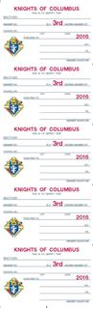

Item #4817 and item #154 can be accessed on the Supreme Website by clicking on Knights Gear/Supplies/Council. Council membership cards are available for distribution on July 1 of the new fraternal year. There is no automatic distribution of membership cards by the Supreme Council. It is the responsibility of the council to order.
Generating Membership Cards

Membership cards can be generated for members using the “Membership Card” section of the Print Center in Member Billing. Print membership cards using the “By Member Type” feature, thereby having these cards ready for presentation when the member remits his payment for dues.

There are four options in “Member Billing” for printing membership cards:

- By Member Type - which can be classified as: All Billable, All Members, Regular, Honorary, Honorary Life, or Members on Disability

- By all members whose dues became current between specified dates

- By Degree Dates - either 1st, 2nd, or 3rd

- Use the Membership Card Template for a small group of members or for new members who have not been added to “Member Billing”.

Click to Return to Resource Topics Table

Membership Numbers

Every member in the Order is assigned a permanent membership number. The membership number is indicated on the Council Statement following any transaction processing involving that member.

When submitting forms or letters to the Supreme Council Office, the Financial Secretary should always use the number of the member involved. Failure to do so may cause delays in processing or in responding to inquiries. The importance of using the membership number cannot be overemphasized.

Click to Return to Resource Topics Table

Membership Transactions

The Form 100 Membership Document is used to report most membership transactions to the Supreme Council office relating to new, present, or former members. Disability exemption and withdrawal are the exceptions. Please refer to the Financial Secretary Resource Guide topics of Disability – Relief from Payment for more information.

As the Financial Secretary, you must be familiar with the membership transactions listed below and how to report them. You can access description of these membership transactions by clicking on the link below to access Knights of Columbus Leader Resources, which is a practical guide for District Deputies, Grand Knights and Financial Secretaries. The membership transactions begin on page 19 of the Knights of Columbus Leader Resources. The numbers in parenthesis indicate the page where these transactions can be located.

http://www.kofc.org/en/resources/officers/officers.pdf

Membership Transactions

New Member (page 19)
Juvenile to Adult (page 19)
Reinstatement (page 19)
Reactivation (page 20)
Readmission (page 20)
Reapplication (page 20)
Transfer (page 20)
Withdrawal (page 20)
Suspension – Nonpayment (pages 20 - 21)
Death (page 21)
Disability – Relief from Payment (page 21)
Suspension – Lack of Practical Catholicity (page 21)
Suspension – Felony Conviction (page 21)
Suspension – Misconduct (page 21)
Honorary Membership (page 22)
Honorary Life Membership (page 23)
Honorary (Honorary Life)
Membership Ceremonial (pages 23 - 24)

Click to Return to Resource Topics Table

Membership Rosters

Council rosters are available on the Knights of Columbus website at www.kofc.org. Each registered officer in the council can access his roster listing by clicking on the Reports Online tab to view or print. These reports are updated weekly. There are also “frozen” rosters dated January 1 and July 1, which are needed for conducting the semiannual audits.

Click to Return to Resource Topics Table

Officers Online – Expert Help & Training

The Expert Help and Training site provides step-by-step instructions to assist members in using Member
Management and Member Billing. This site can be accessed by clicking on the Expert logo in the upper right-hand corner of any screen in these applications, or by going to http://www.kofc.org/experthelp.

Additionally, a training site for these applications has been added, which can be accessed by clicking on
the Sign-In – Officers Training link located in the upper right-hand corner on the Expert Help site. This training area allows the user to update records and generate transactions in a test environment.

Officers Online — Financial Secretary Section

The Officers Online website, accessed from the main Knights of Columbus webpage, provides you with access to your council’s membership roster and financial statement. Your access to this website is granted once your appointment is approved by the Supreme Knight. This site lets you keep track of your council’s progress for both membership and insurance growth, which is useful information toward the earning of the Star Council Award.

After signing into Officers Online, as Financial Secretary, you can order council supplies, which can be charged to your council’s account. Gift items are also available by clicking on the Knights Gear logo, which brings you to knightsgear.com. Through this website, your council can also order customized apparel (e.g. t-shirts with your council’s name and number). A Requisition (#1) is no longer needed to order supplies and gift items when ordering through this website. Please refer to the “Ordering Supplies” Resource Topic Tab located on page 17 of this document.

Another resource available through Officers Online is the Officers’ Desk Reference. It provides answers to
frequently asked questions about our name and emblem, home corporations, membership issues, tax issues,
fraternal issues, council and assembly issues, the Fourth Degree and social communications. There’s a very good chance that many of the questions you might have about some of the more challenging aspects of being a financial secretary have been dealt with here. Entries are regularly updated and expanded as new questions arise or additional information becomes available.

The Order’s accounting system and member database, Member Management/Member Billing, is also located in the Officers Online section of the Order’s website. This system allows you to manage financial transactions; create, edit and archive receipts, vouchers, assessments and adjustments; maintain a list of accounts and sub-accounts, payee/payor lists and council defined sub-classes for billing (military, students, etc.;), produce billing notices; and manage payments received from members.

PLEASE GO TO THE “ACCOUNT KEEPING” RESOURCE TOPIC TAB TO ACCESS INFORMATION REGARDING THE MEMBER BILLING APPLICATION.

Click to Return to Resource Topics Table

Oklahoma State Council Forms

Please click on the link http://kofcknights.org/StateCouncilSite/StateCouncilForms.asp?CN=US&ST=OK to access various Oklahoma State Council Forms from the categories listed below. Each of these categories contains forms and information you may need as Financial Secretary. Please scroll down to access all of the topics listed below.
State Secretary/Council Forms

Membership Forms

General Program Forms

Intellectual Disabilities (Tootsie Roll Information)

Center of Family Love (Love Challenge Materials)

Leadership /Officers (Leadership Resources for Officers)

Click to Return to Resource Topics Table

Officers’ Desk Reference

Each one of the links below contain important information that can be accessed by logging into Officers Online and clicking on Officers’ Desk Reference. The first link below concerning the process of receiving and expending council money, provides a clear and concise overview of the financial duties of council officers. Please make sure you familiarize yourself with all these financial issues. Click on the links below to access the information:

Financial Issues
- The Process of Receiving and Expending Council Money
- Section 122(b) – The “$500 Rule”
- Financial Officer Bonding Program
- Financial Secretary - IRS Reporting Requirements
- Guidelines for Charitable Contributions
- Knights of Columbus Charitable Giving Accountability Standards
- Investments
- Electronic Banking and Payment Services
- Guidelines for Charitable Fundraisers
- When Money Goes Missing
- Audit Requirements/Guidelines
- Officer Use of Debit and Credit Cards

Click to Return to Resource Topics Table

Order on Treasurer

After a bill has been properly approved for payment, the Financial Secretary initiates issuance of a check by generating a voucher (Order on Treasurer) in Member Billing under the Voucher section of the Council Ledger. He then prints a Report of Vouchers for the Grand Knight’s signature which authorizes the Treasurer to issue the check. Instructions, specific recorded webinars and Help are available within the online applications.

Trustees, in conducting the semi-annual audit, should make certain that the stubs (if the Financial Secretary is using the blue book) in the possession of the Financial Secretary and the vouchers held by the Treasurer, agree. Also, the vouchers should be compared with the checks issued.

Trustees, when conducting the semiannual audit, should compare the Report of Vouchers to the checks issued that are recorded in the bank statement and check book. Some Treasurers, after receiving the cancelled checks from the bank, clip the vouchers and the checks together, thus facilitating the work of the trustees.

Click to Return to Resource Topics Table

Ordering Supplies

If you have a question about an order you can contact the Supply Department at the Supreme Council Departmental Telephone at (203) 752-4000.

You can also contact the following:

Supply General Information at extensions 4214, 4451, 4244

Supply Agency at 4320, Gift Department at 1-855-432-7562

Supply Fax at Supply 1-800-266-6340

The fastest and easiest way to order supplies is to go through Officers Online.

• Authorized persons with access to Officers Online should log on to order supply materials and gift
items via the Knights Gear website by clicking the Knights Gear logo.

• A Requisition (Form #1) is not required when ordering through this website.

After you sign in at Officers Online and select Knights Gear to enter the store you can do it two ways.

- Click on supplies under Categories to find the item you need or enter a word such as Soccer in the Search field.

2. Find the item you need.

3. Select language if applicable.

4. Select quantity you need, read details to know if items are packaged in multiple quantities.

5. Add to cart if you are ready to place the order.

6. Add to Wishlist if you are placing the order at another time.

7. When you select Add to Cart, review your order for item and quantity.

8. Click on Estimate Shipping to know your cost for Ground, Next Day, or 2nd Day delivery, Standard Rate is Ground.

9. Click on Checkout or Continue Shopping if you are ordering other supplies.

10. At Checkout verify Billing Address, Shipping Address, Payment Method, Payment Information
and Confirm.

Click to Return to Resource Topics Table

Privacy of Membership and Financial Information
Councils should safeguard their membership information and financial information, taking reasonable measures to ensure that such information is not improperly disclosed or misused.
For all entries under the Protection of Membership and Financial Information tab of the Officers' Desk Reference, the following definitions shall apply:
- Council shall refer to all State and Local Councils, Assemblies, and Chapters.
- Membership Information refers to a member’s personal identifying information, including, but not limited to, full name, date of birth, membership number, Social Security Number, residential address, email address, and phone numbers.
- Financial Information refers to a council’s business records, including, but not limited to, bank accounts, account balances, membership rosters, members’ dues payments, receipts, accounts payable, semi-annual audits, Employer Identification Number, and tax records.
Membership information and financial information should not be published or distributed in hard copy or electronic/digital format (email, website, social media), unless required for ordinary fraternal business, and only the minimum amount of information should ever be disclosed. Never publish or distribute personally identifiable information such as date of birth, social security number, or bank account numbers or balances. If, for some reason, personally identifiable information needs to be transmitted or distributed electronically, the information should be encrypted.
During business meetings, officers may disclose information, to the extent that it is relevant and necessary, in the course of delivering a report. Officers should use care when including membership information and financial information in published meeting minutes, including such information only when necessary.
With respect to members’ full social security numbers, there is no reason for councils to request or store this information. Although previous versions of the Form 100 included a space for an applicant to disclose his social security number, the form has been changed so that this information is no longer requested. To the extent that councils have stored documents (in hard copy or electronic/digital format) that contain the social security number of any member or applicant, that information should be deleted or redacted.
Click to Return to Resource Topics Table

Records Management

On occasion, Financial Secretaries inquire as to how long council records should be retained. Be guided by the following:

- Current member Form 100s (new members, reentry transactions for members who did not join through your council originally): 7 years

- Current member Form 100s (all except above and data changes): 3 years

- Current member Form 100s (data changes): verify processing at the Supreme Council Office, then destroy

- Former member Form 100s (all transactions): verify processing at the Supreme Council Office, then destroy

- Financial and business records (e.g. bank statements, contracts, purchase orders, invoices):10 years

- Tax Forms: 7 years minimum, 10 years recommended

- Correspondence and accounting records: 3 years
- The monthly Council Statements should be retained by the Financial Secretary as part of his permanent files.

- In all cases, tax ID numbers—including the last four digits—must be obliterated.

Click to Return to Resource Topics Table

Report of Officer Elections

Section 128 of the Charter Constitution and Laws of the Knights of Columbus states that elections of subordinate council officers shall be held between May 15 and June 15 of each year (college councils – March 1 to June 1). Those duly elected officers are to be reported to the Supreme Council office through the Council Administration tab of Member Management of Officers Online. Make sure you are on the “Council Officers - Next Fraternal Year” screen and simply follow the instructions included on the site for completing the form. When done, go to the Print Center-MM tab and create copies to email to the State Deputy, District Deputy, and Grand Knight (Supreme gets one automatically). Save a copy for your council file. Deadline for reporting is July 1.

Changes to officers during the fraternal year can be accomplished the same way, except using the “Current Fraternal Year” screen instead.

Should access to Officers Online not be available, use Form 185 by clicking on the link.
http://www.kofc.org/en/members/resources/forms/council.html

Click to Return to Resource Topics Table

Safe Environment Training

Throughout its history, the Knights of Columbus has promoted Christian family life in all its initiatives and programs, including those serving children and youth. Recognizing that children are a precious gift and “the living reflection” of familial love, their safety and well-being is the greatest priority in Knights of Columbus youth programs and activities.

The Knights of Columbus Safe Environment Program protects young people against risks of abuse and neglect. The Safe Environment Program consists of a thorough youth leader screening process, child abuse awareness training, and a robust reporting procedure in the event of possible misconduct.

Please click on the link below for more information:

http://www.kofc.org/en/members/programs/youth-activities/safe-environment-program.html

Please click on the link below to access frequently asked questions about the Supreme Council Safe Environment training.

https://www.kofc.org/en/resources/members/safe_environment_faq.pdf

Click to Return to Resource Topics Table

Service Program Personnel Report

The Service Program Personnel Report, should be completed by the newly elected Grand Knight or current Financial Secretary as soon as a majority of the council’s Service Program personnel have been appointed for the fraternal year. Receipt of report at the Supreme Council Office by August 1 is a requirement for the Star Council, Award and comprises the mailing list of Service Program personnel for special programming materials including Knightline.

Those appointed personnel are to be reported to the Supreme Council office through the Council Administration tab of Member Management of Officers Online. Make sure you are on the “Service Program - Current Fraternal Year” screen (Next Fraternal Year screen if being completed by a reelected GK or FS before July 1) and simply follow the instructions included on the site for completing the form. When done, go to the Print Center-MM tab and create copies to email to the State Deputy, District Deputy, and Grand Knight (Supreme gets one automatically). Save a copy for your council file.

Changes to officers during the fraternal year can be accomplished the same way.

A reminder, that a Retention Chairman must be listed on the report before the Supreme Council will approve the suspension of a member.

Should access to Officers Online not be available, use Form 365 by clicking on the link
http://www.kofc.org/en/members/resources/forms/council.html

Click to Return to Resource Topics Table

Star Council Award

The Star Council Award recognizes outstanding achievement in membership, insurance and service program activities. To be eligible for the Star Council Award a council must qualify for the Father McGivney, Founders’, and Columbian awards. The deadline for submission of the Columbian Award is June 30. Please click on the link below to view more information concerning the Star Council Award.

http://www.kofc.org/en/members/programs/council-activities/star-council-award.html

Click to Return to Resource Topics Table

State Per Capita

Pursuant to Law, the Financial Secretary is notified that the State Per Capita Tax and Public Relations Assessment for the current fiscal year are due August 31 and payable NO LATER than November 20 of the current fiscal year.

Per Capita Tax is billed at the rate of $8.50 for each Regular member and $4.25 for Honorary members. Inactive members are billed at the rate of $3.00 which is reimbursed to the council by the Supreme Council. The Public Relations Assessment is billed at the rate of $1.50 per each Regular, Inactive (reimbursed by the Supreme Council as well), and Honorary members.

Your council's tax is based upon the assessable membership as of April 1. Make your check payable to “Knights of Columbus Oklahoma State Council”. Mail the check to the State Secretary Matt Maly - PO Box 851476 - Yukon, OK 73085-1476.

Once again, you do not need council approval of the members at a regular business meeting to pay these assessments from the State Council.

Click to Return to Resource Topics Table

Supreme Per Capita

Councils are assessed $1.75 on January 1 and July 1 for per capita tax on the total membership including inactive and honorary members but excluding honorary life and disabled members. Concurrently, councils are also assessed 50¢ for Catholic Advertising and $1.00 for the Culture of Life on the same basis as per capita. On occasion, the Board of Directors implements special assessments for financing various worthy projects and causes. Any such levies are additional.
Each month the Grand Knight receives his own Membership and Financial Statement (Form #1189). The report shows the progress the council is making in its membership/insurance programs.

The Financial Summary section indicates the council’s financial standing in relation to the Supreme Council. This statement is a condensed version of the monthly Council Statement received by the Financial Secretary. You do not need council approval of the members at a regular business meeting to pay these assessments from Supreme.

Click to Return to Resource Topics Table

Survey of Fraternal Activity

Form #1728 is used to measure the success of various programs in a council throughout the fraternal year. The deadline to send Form 1728 to the Supreme Council office is January 31 of each fraternal year. Click on the link below to access Form 1728:
http://www.kofc.org/en/forms/council/fraternal_survey1728_p.pdf

Each council should keep accurate records of the number of charitable hours donated by every brother knight, their family members as well as nonmembers. For example, many councils work in food pantries at their church or local charities. A council may record that members spent 5 hours working on a food drive. However, if 8 people including knights and nonmembers worked on the food drive, the number of hours should be reported as 40 hours. The total hours for an activity is the number of hours multiplied by the number of people who participated in that activity.

Please click on the link below to access Form #,1728a, which is an individual member’s Survey of Fraternal Activity Worksheet.
http://www.kofc.org/un/en/forms/council/individual_survey1728a_p.pdf

Click to Return to Resource Topics Table

Suspension of Council

The Financial Secretary should always be aware of the need to make payments to the Supreme Council within the time limits allowed under Section 156 (Charter Constitution and Laws of the Knights of Columbus) of the Order’s Laws. http://www.kofc.org/en/forms/leadership/charter-const-laws30.pdf

Failure to make payments within the time limit will result in the suspension of the council. When a council is suspended, the Board of Directors requires the Supreme Secretary to send a Notice of Suspension to the Grand Knight, with copies to the District Deputy and State Deputy.

Section 156 (Charter Constitution and Laws of the Knights of Columbus) provides a grace period of 100 days for each levy from the first of the month in which the levy is made. The assessment dates and the dates on which they become in arrears are as follows:

Levy Date Type of Levy Pay by

January 1 Per Capita/Catholic Advertising April 10
July 1 Per Capita/Catholic Advertising October 10

Supplies – 40 days after the first of the month in which the charge appears on the monthly Council Statement.

The above information is of importance to the Financial Secretary and the Grand Knight. A council is suspended automatically whenever there is an arrearage of $50.00 or more in any of the above accounts.

Even though the council has a 100-day grace period to remit and receive credit for payments, automatic notices to the Grand Knight, Financial Secretary and District Deputy will be generated between 58 and 60 days from the date of assessment. This notice is a reminder to forward your payment to avoid automatic suspension. It is not the official Notice of Suspension.

A council may have its suspension lifted by merely making payment of the amount in arrears. When a council is to be reinstated, Notice of Reinstatement is sent to the aforementioned officers.

Click to Return to Resource Topics Table

Tax Form 990N

All councils in the United States are exempt from federal income tax under the Internal Revenue Code, Section 501 (C) (8). A group ruling recognizing the exemption was obtained by the Supreme Council for itself and for its subordinate units. The group ruling does not extend to home corporations.

All councils file one of the following:
• 990N – Gross receipts normally less than or equal to $50,000.00 (electronic format only, click on the link below for more information.

IRS Form 990-N Electronic Filing System (e-Postcard)

• 990EZ – Gross receipts less than $200,000, and total assets less than $500,000.

• 990 – Gross receipts greater than or equal to $200,000, or total assets greater than or equal
to $500,000

The Supreme Council insists that each such subordinate council carry out its responsibilities under this law. Form 990 must be filed by the fifteenth day of the fifth month after the end of your annual accounting period. Failure to file 3 consecutive years will result in a loss of tax exemption status. To keep abreast of the current laws in these matters, the Supreme Advocate will send a memorandum to all U.S. councils during the month of February of each year.

Please contact Joaquin Patlan, the Financial Secretary at St. Joseph Council 12819 in Norman, if your council has been suspended for failure to file for 3 consecutive years. Joaquin has graciously volunteered to walk your council officers through the steps to be reinstated to a tax-exempt status. Joaquin will be looking for changes, if any, for 2017 tax year and will assist anyone in the next tax season. You can contact him at jpatlan@cox.net. We certainly appreciate Brother Patlan's willingness to share his expertise and experience regarding the 990N form with others.

You can also contact our State Advocate, Chris Victor, at cmvictor1@cox.net, if you have any questions about the 990N form or Home Corporations.

If your council’s annual accounting period ends December 31, ensure that your council submits the proper IRS Form 990N by May15.

If your council’s annual accounting period ends June 30, ensure that your council submits the proper IRS Form 990N by November 15.

Click to Return to Resource Topics Table

Treasurer Duties

The duties of the Treasurer are outlined in Section 140 of the (Charter Constitution and Laws of the Knights), that can be accessed by clicking on the link http://www.kofc.org/en/forms/leadership/charter-const-laws30.pdf

SEC. 140. The Treasurer shall perform the following duties:

Custodian of Funds

1. Be the custodian of all funds of the council obtained from any source, by or through any person or persons, acting for or in the name of the council or under its direction or authority.

Receive Moneys, Etc.

2. At each meeting of the council receives from the Financial Secretary all moneys whatever received by said Secretary at such meeting, or between meetings, and shall give a written receipt to such Secretary therefor, specifying the funds to which the same shall be credited.

The moneys so received by such Treasurer shall be forthwith deposited by said Treasurer to the credit of the council in an approved bank or other secure institution of deposit, subject to approval of the Board of Trustees or majority vote of the council. He shall obtain vouchers or certificates of deposit therefor, a copy of each of which shall be delivered by such Treasurer to the acting Grand Knight before the next succeeding meeting. His deposit books may be accepted as such vouchers.

Pay to Supreme Secretary

3. He shall pay to the Supreme Council all moneys assessed by it or by the Board of Directors against his council upon order drawn and signed by the Financial Secretary and countersigned by the Grand Knight. Payment to the Supreme Council shall be by check, money order or draft, payable to “Knights of Columbus, Supreme Council” and no other form of payment shall be received by the Supreme Secretary nor shall any other form of payment discharge the subordinate council of its obligation.

Pay Orders Drawn

4. He shall pay all orders drawn on him which are signed by the Financial Secretary and countersigned by the Grand Knight. All such orders shall have the approval of the Board of Trustees, except demands of the Supreme Council, Board of Directors or State Councils, and the regular and usual stated payments of the council and payments authorized by the council after notice and vote in accordance with Section 122. Payment of all orders shall be by check, money order or draft signed by the Treasurer and countersigned by the Grand Knight.

Keep Accounts

5. He shall keep separate accounts of the moneys placed in his hands by his council or the officers thereof that shall plainly show at all times the amount of moneys in the general expense fund of the council, and the amount of moneys in each and every special fund of such council and the dates of receiving and disbursing the same; such accounts to be kept in books furnished by the Supreme Secretary to such Treasurers at the expense of their respective councils.

Retain Orders

6. He shall retain all orders of the Grand Knight as his vouchers.

Click to Return to Resource Topics Table

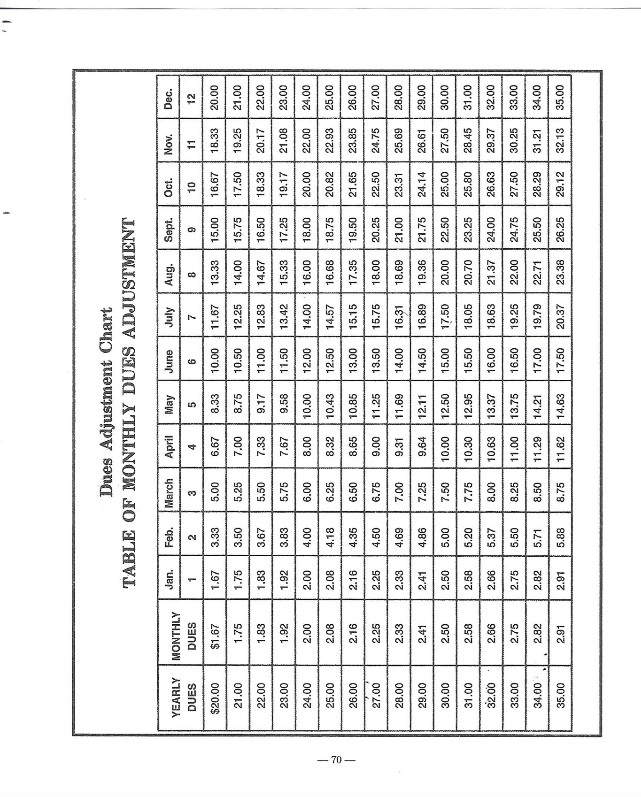

Dues Adjustment Chart
(from Financial Secretary Handbook (page 70) Revision Date of 12/2012)
Click to Return to Dues Adjustment Chart resource topic

Illustrations 1 - 12
(Note: Scroll down to view Numbered Illustration)

Click here to return to “Account Keeping Section”

Illustration # 1
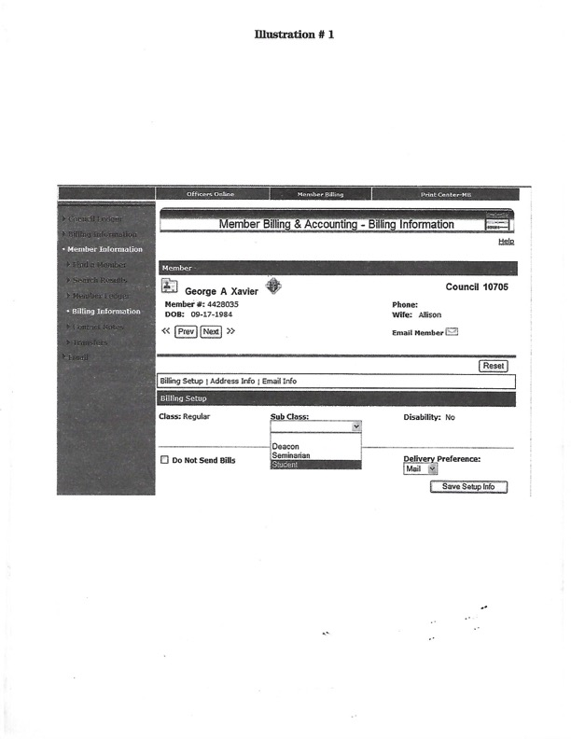

Click here to return to “Account Keeping Section”

Illustration # 2
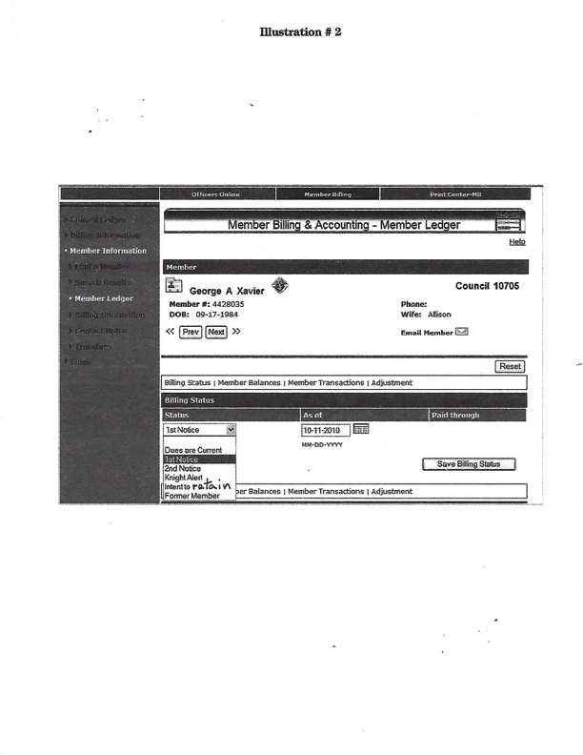

Click here to return to “Account Keeping Section”

Illustration # 3

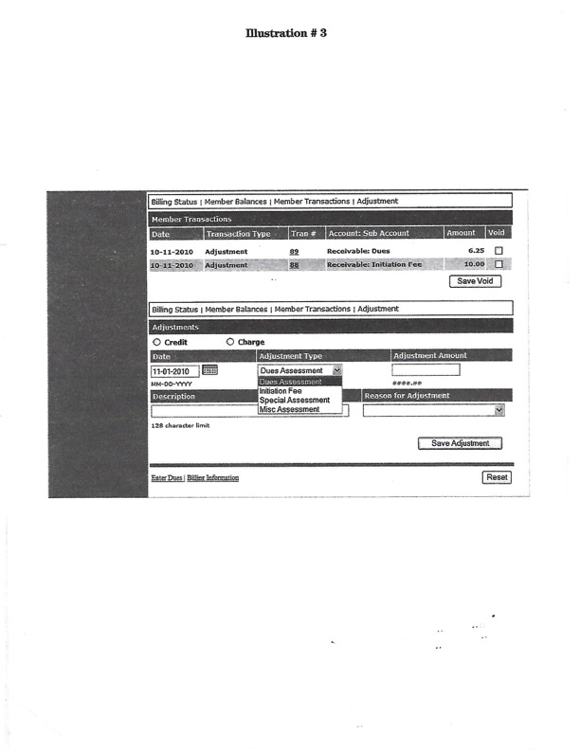

Click here to return to “Account Keeping Section”

Illustration # 4
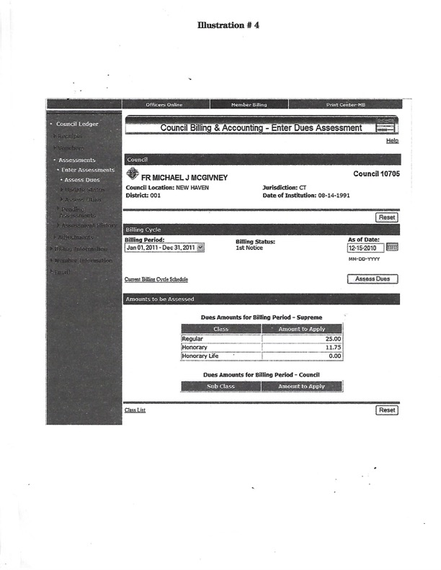

Click here to return to “Account Keeping Section”

Illustration # 5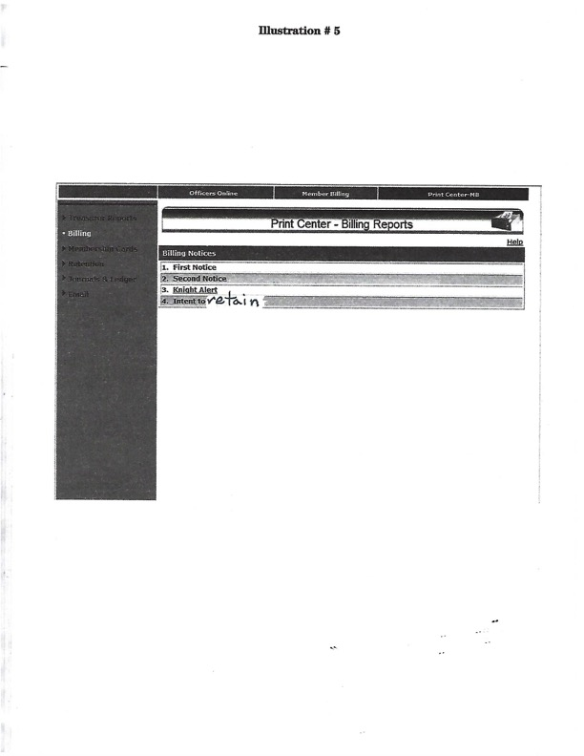

Click here to return to “Account Keeping Section”

Illustration # 6

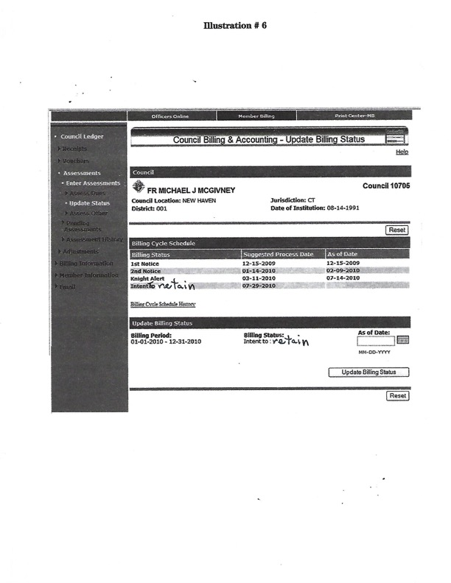

Click here to return to “Account Keeping Section”

Illustration # 7

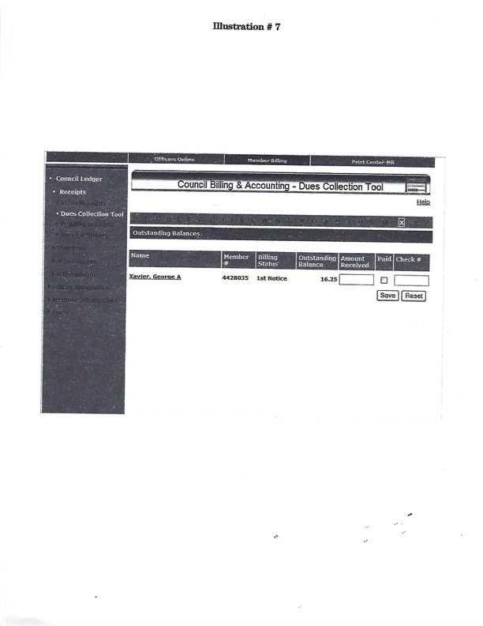

Click here to return to “Account Keeping Section”

Illustration # 8

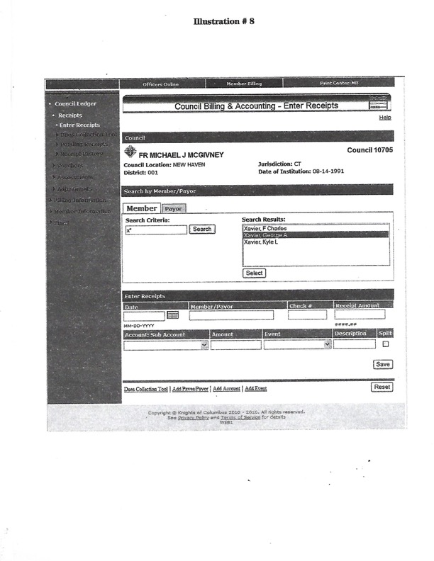

Click here to return to “Account Keeping Section”

Illustration # 9

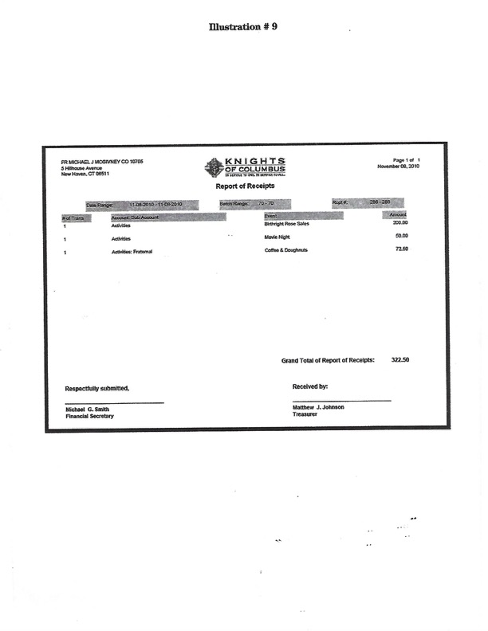

Click here to return to “Account Keeping Section”

Illustration # 10

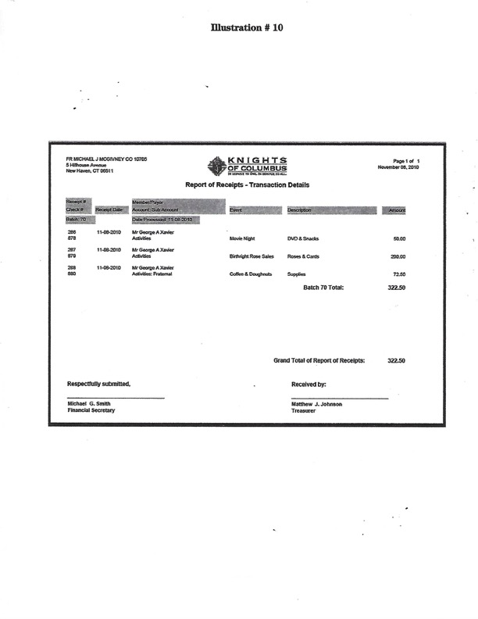

Click here to return to “Account Keeping Section”

Illustration # 11

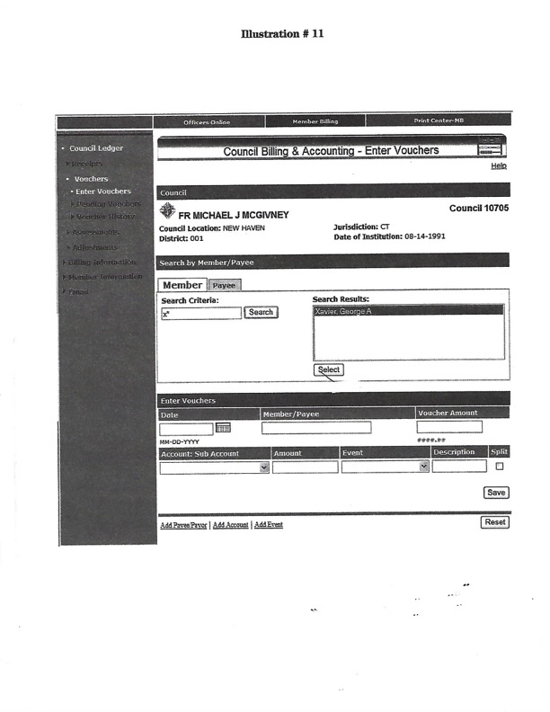

Click here to return to “Account Keeping Section”

Illustration # 12

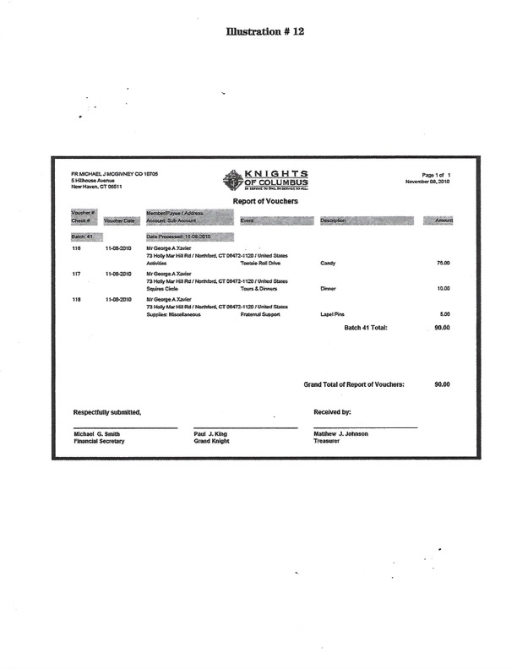

Frequently Asked Questions

Click to Return to Resource Topics Table

Table of Contents

Resource Topics Location Number of Questions

ACCOUNT KEEPING Pages 53 to 54 Eight

BONDING Pages 54 to 55 Five

COUNCIL FINANCIAL TEAM Page 55 Two

COUNCIL STATEMENT Page 56 One

DATA CHANGE Page 56 One

DUTIES Page 56 Four

FINANCIAL SECRETARY EVALUATION Page 57 Five

HONORARY MEMBERSHIP Page 58 One

INSURANCE Page 58 Two

MEMBERSHIP CARDS Page 58 One

MEMBER MANAGEMENT Pages 59 to 60 Eight

MEMBERSHIP NUMBERS Page 60 One

MEMBERSHIP ROSTERS Pages 60 to 61 Three

MEMBERSHIP TRANSACTIONS Pages 61 to 62 Six

OFFICERS ONLINE -
EXPERT HELP & TRAINING Page 62 Two

ONLINE MEMBERSHIP Pages 63 to 64 Seven

TAX FORM 990N Pages 64 to 65 Five

ACCOUNT KEEPING

How do I assess new members or transfers when they appear on my system for the first time?

To assess a new member in your council, you must make adjustment(s) on the member ledger. The first adjustment will be the type “Dues Assessment.” For new members, an additional adjustment is required for “Initiation Fee.”

ACCOUNT KEEPING

When a member transfers out of my council, his ledger is deleted. How do I know if he had an outstanding balance?

In Member Billing under Member Information there is a Transfers section, which allows you to search using the Transferred Member Ledger. This screen provides the information needed to complete the Transfer Account Adjustment form and allows for clearing any outstanding balances.

ACCOUNT KEEPING

Will the new council be able to see the payment records and notes I’ve made in the past?

When a member transfers in, only Member Management information on the member will be available to the new council/assembly. No member billing information is viewable.

ACCOUNT KEEPING

I would like to be able to look at the pending assessments/dues bills before printing them to
confirm that they are correct. How do I proceed?

The application will not give you the opportunity to view each individual member bill prior to processing the “Pending Assessments.”

To assure that the assessments will process correctly, after you have generated the assessment (Clicking on the “Assess Dues” button in the council/assembly dues process or the “Assess Other” button in the Special/Miscellaneous process) you should review the amounts on the “Pending Assessments” screen (Council Ledger/Assessments/Pending Assessments.)

If the total properly reflects the amount to be billed (and adjusted), click on the “Process Assessments” button. If for some reason a member’s bill is wrong, an adjustment can be made on the member’s ledger.

ACCOUNT KEEPING

I inadvertently assessed dues for the current year, not the new year. How do I back it out?

You must go to each Member’s Ledger and void the incorrect transaction. Make sure you choose the correct assessment if there is more than one listed on the member’s ledger. Once all of these assessment transactions are voided, go into the Assessments screen and assess dues for the proper billing period.

ACCOUNT KEEPING

I posted a special assessment as mandatory. Is there a way of changing it to voluntary?

Since assessments cannot be edited, the only way to change an assessment is to delete it while it is still a “Pending Assessment” and then re-enter it. Once an assessment has been posted/processed, the only way to change it is to void the assessment on each Member’s Ledger and then re-enter it as a voluntary assessment.

ACCOUNT KEEPING

I made my assessment, but none of the bills show up. Why?

Make sure you have processed your pending assessment and/or clicked the “Update Status” button. Refer to the “Pending Assessments” page in the “Council Ledger/Assessments” or section. The Member Billing landing page (“Council Ledger” or “Assembly Ledger”) also has any pending transactions indicated near the bottom of the page.

ACCOUNT KEEPING

How do I print membership cards for one or a few members?

For each membership card you wish to print, set the Billing Status (on the top of the Member Ledger page) to “Dues are Current” and set the “As of” date to an arbitrary value (such as 1-02-2018).

When you print membership cards, select the tab that says “All Members Whose Dues are Current” (instead of the default “By Member Type.”) Set the “Show from” and “to” dates as 1-02-2018 (your arbitrary date) and click on the “Print Cards” button. Be sure to re-set the “Billing Status” and “as of” values when completed. There is a future plan to allow the printing of individual membership cards via the Member’s Ledger.

BONDING

What is the bonding for financial secretaries and treasurers? How does a council secure it?

Bonding in the amount of $5,000 is provided for financial secretaries upon appointment. Treasurers are covered upon receipt of an Officer Report #185. Bonding is on the position, not the person.

BONDING

Can a council purchase additional bonding? How much does it cost?

Yes. The charge for additional bonding is $7.00 per thousand of additional insurance. A written request for additional coverage must be made to the Supreme Secretary’s office. The charge for the additional insurance will appear on the next council billing statement and will be pro-rated as necessary. Bonding begins on March 1 and runs through the end of February.

BONDING

Is there a limit to the additional bonding a council can purchase?

Yes. Bonding on the financial secretary and treasurer is limited to $125,000 of total coverage per council, including the provided $5,000 of coverage on each officer.
.
BONDING

Who sets the bonding limits for a council?

The council’s Board of Trustees sets the bonding limits of the Treasurer and Financial Secretary for a council.
BONDING

How does a council make a claim for bonding coverage?

Claims for bonding coverage are made to the Legal Department who investigates the request and subsequently pays the claim, if deemed appropriate. In order for the bond to be in effect, the past two semiannual Council Audits #1295 must be on file at the Supreme Council office.

COUNCIL FINANCIAL TEAM

Can a grand knight remove a financial secretary from office?

No. Only a state, district or territorial deputy may declare any office in a subordinate council vacant, and only in cases where the officer fails or refuses to perform the duties of his office.

COUNCIL FINANCIAL TEAM

Why can’t a student serve as financial secretary of a college council?

At the October 1991 meeting of the Board of Directors, it was voted that new college councils may not be instituted unless a member of the faculty or staff of the school or a permanent member of the local community has agreed to serve in the position of financial secretary. It was further voted that this regulation should also apply to financial secretary reappointments in all college councils.

The reason for this regulation is to provide both a consistent point of contact for the state council and the Supreme Council, and to provide the college council with a consistent campus presence. That helps ensure that the council won’t have to “start from scratch” at the beginning of a school year if most or all of the student officers have graduated.

COUNCIL STATEMENT

I see a credit on my council statement for $7.50 ($5.00) with a name and number for a member
that has not applied for re-entry into our council or left our council by suspension or withdrawal some time ago. Why are we receiving this credit?

The member has re-entered the Knights of Columbus through another council. That council was responsible for collecting the re-entry fee, which is passed along to your council by the credit appearing on your monthly statement.

DATA CHANGE

A member contacted me to say that his address has been changed to his son’s address. Why?

We receive a listing monthly from the Postal Service of those members who have reported an address change. Under certain conditions, family member with the same prior address are changed as well. If you notice that an address has been changed in error, please report it to us as soon as possible.
DUTIES

Can the financial secretary serve in another officer position?

Within the council the financial secretary cannot serve in another elected office. There are no limits,
however, to his serving in another elected office outside of the council.

DUTIES

Should the financial secretary serve on the council retention committee?

No. The Retention Committee should include the grand knight, chairman ex officio; membership director; retention chairman; trustees; and proposer, if available.

DUTIES

Why does a financial secretary need to complete a W-9 Request for Taxpayer Identification Number form?

The Request for Taxpayer Identification Number must be on file in the Supreme Council office in order to receive the financial secretary compensation paid by the Supreme Council. Money paid under this compensation program is reported to the Internal Revenue Service. Those financial secretaries who receive payments in excess of $599.99 will receive a 1099-Misc.

DUTIES

What constitutes financial secretary compensation?

From the Supreme Council, paid annually at the end of each calendar year…forty cents for each life insurance certificate registered through the council. From the local council… an amount equal to not
less than eight percent and not more than ten percent (as stated in the council by-laws) of moneys collected for dues only. The financial secretary is free to waive this compensation at his discretion.

FINANCIAL SECRETARY EVALUATION

What must a council do to get a new Financial Secretary appointed?

If the financial secretary of record is resigning, he should submit a letter of resignation addressed to the Supreme Knight. If the grand knight and trustees do not wish the financial secretary to be reappointed, they should so indicate on the Evaluation Form #1938.

Upon receipt of the resignation letter or the evaluation form not recommending reappointment, the Supreme Council office will provide the grand knight with a Nomination Form #103 (to be completed by the grand knight and trustees) and Application Forms #101 (to be completed by the prospective candidates).

FINANCIAL SECRETARY EVALUATION

Why does an Evaluation Form need to be completed?

The Evaluation Form #1938 advises the Supreme Knight of how effectively the financial secretary is performing his duties. Completed near the end of the financial secretary’s three-year term, this form allows for the grand knight and trustees to recommend/not recommend reappointment.

FINANCIAL SECRETARY EVALUATION

Will a financial secretary be automatically reappointed if he wishes to remain in the position?

Not necessarily. The Evaluation Form #1938 gives the grand knight and trustees the opportunity to either recommend or not recommend reappointment. If reappointment is recommended, a letter of reappointment will be forwarded to the financial secretary. If the form is not received within 120 days following completion of the financial secretary’s term of office, he will be reappointed automatically.

FINANCIAL SECRETARY EVALUATION

Why does a financial secretary have to send a letter of resignation if he is at the end of his term?

To confirm that he is leaving office of his own accord. If, after 120 days from the conclusion of his term, a (1) letter of resignation or (2) an evaluation form not recommending reappointment has not been received, the financial secretary will be reappointed automatically.

FINANCIAL SECRETARY EVALUATION

Is there a special form for resignation?

No. A letter of resignation from the financial secretary addressed to the Supreme Knight should be forwarded to the Financial Secretary Appointments Division.

HONORARY MEMBERSHIP

Priests are awarded the honorary life distinction upon receiving the First Degree of the Order. Why are permanent deacons not awarded this same distinction?

While deacons are certainly recognized by the Order as belonging to religious communities, the original intent of awarding honorary life to priests was to compensate for the meager salaries common to the priesthood. Normally, permanent deacons are employed full time in other than a religious vocation and with higher compensation.

Thus, permanent deacons are only eligible for the honorary and honorary life distinctions upon satisfying the normal age/years of service requirements.

INSURANCE

I received a letter regarding a person who has applied for insurance coverage but is not yet a member. What should I do?

This situation arises when an applicant purchases insurance under the 90-day membership exclusion and your council number is listed on the insurance application.

Under this exclusion the applicant has 90 days in which to join the Knights of Columbus or risk cancellation of any insurance coverage. Thus, when you receive a copy of one of these letters – whether the original was sent to the writing insurance agent or to the applicant – we are asking your cooperation in seeing that a Form 100 Membership Document is forwarded to our office reporting his initiation as soon as possible and within the 90-day period.

If the applicant has not received his degree, we would ask that you contact him and the writing
agent as soon as possible to arrange for him to receive the First Degree.

INSURANCE

I have been informed of the death of a member but I don’t have the complete date (mm/dd/yyyy) of death. How do I proceed?

The full date of death is necessary for us to process a death transaction. In the United States you can visit\ the RootsWeb.com site on the Internet and click on social security death index. It is free and the social security number is not required to search. Similar websites are available in other countries. Use your favorite search engine to locate one.

MEMBERSHIP CARDS

Why can’t the Supreme Council office send the proper number of membership cards to each
financial secretary annually, instead of us having to order them?

Councils use different accounting systems: the Peg-Board or other manual system, the on-line member management/billing application, the PC-based FSPC software program or another locally developed spreadsheet application. These can require different card formats.

Since errors, multiple issues and replacement cards can occur under any system, it is difficult to project the number of blank cards per council. Councils are also expected to recruit new members, adding to the potential count. Thus, the financial secretary is in a better position to estimate the proper number of cards needed.

MEMBER MANAGEMENT

Why does the roster show so many members as only having received the First Degree when we know that many are Third Degree members?

In the past the fraternal system did not support storing Second and Third-Degree dates. This information was normally retained by the local council. While we now have the capability to store all degree dates, many have never been provided to us. If degree information is known, it should be reported to the Supreme Council office. The easiest way to do so, is to update those fields using the on-line Member Management application. If an exact date is unavailable, simply report “yes.”

MEMBER MANAGEMENT

Who has access to Member Management/Billing?

Member Management: Grand knights and financial secretaries have access to council information. Member Billing: Only financial secretaries have access to council information

MEMBER MANAGEMENT

When will my new members appear on the database?

Any membership document processed by the Membership Records Department during a given work week will be added to the Member Management/Billing data base on the following Tuesday.

MEMBER MANAGEMENT

I entered data changes yesterday on Member Management and they are not yet listed on my roster. Why?

Changes reported through Member Management are not entered directly into the client/member record. They must be re-keyed by clerks in Membership Records. Member Management rosters are updated on Tuesdays.

MEMBER MANAGEMENT

How can I view my council members on one screen?

Due to data base constraints, search results in Member Management and Member Billing will not return a list of all of your members on one screen. You can view all of the members’ last names that start with a particular letter by placing that letter followed by an asterisk in the search box.

MEMBER MANAGEMENT

Can I print addresses to an envelope rather than to a label?

You will need to use the Data Extract Tool in the Member Management Print Center to create a spread sheet and then create a merge document to generate the envelopes.

MEMBER MANAGEMENT

What do I do if information doesn’t print in the correct location on labels and membership cards?

Our recommendation is to set the “Page Scaling” option in the Adobe Print dialogue box to the “Shrink Large Pages” setting. Print a test page, and then adjust the “Page Scaling” until you find a setting that works for you. For membership cards, some users report setting the page scaling to “Shrink to Printable Area” and then trimming 1/4 inch off the top of the card. Printers handle files differently. We know of no way to overcome every print issue.

MEMBER MANAGEMENT

Do I have to submit a Form 100 for an address change, or can I report it on-line?

The preferred method is to enter this information on-line through the Member Management program. Please include apartment or building numbers, where applicable.

MEMBERSHIP NUMBERS

How do I obtain membership numbers and degree dates for members entering my council by transfer or re-entry?

If membership numbers and/or degree dates are not available at the time of application, you can submit the Form 100 without them. Simply include on the form what information you have available. In the case of transfer, this information will usually be provided by us or the former council on the Transfer Account Adjustment Form 142. If not – and in the case of reentries – check the council roster on the Order’s website. Web-based rosters are updated weekly.

MEMBERSHIP ROSTERS

On my roster, there is an asterisk preceding the member’s address, and he has not been receiving his mail. What is the problem and what does this asterisk mean?

The asterisk means that the member’s mail has been restricted due to previous mailings being returned as “undeliverable.” If the address is verified by either the member or his council, this restriction will be removed.

MEMBERSHIP ROSTERS

How can I receive a copy of my council roster?

Rosters on the Order’s website at www.kofc.org are updated weekly and can be accessed by financial secretaries or grand knights. In addition to the current rosters, rosters dated January 1 and July 1 are also available for audit purposes.

MEMBERSHIP ROSTERS

What are inactive members, and why do they appear on my council’s roster?

Inactive members are insurance members in an exit status, either by suspension or withdrawal, and thus are no longer in good standing in the Order. However, because they have in-force Knights of Columbus insurance, they are retained on your rolls to satisfy the requirements mandated by the insurance commissioners in the various jurisdictions we serve. Inactive members are subject to Supreme and state-levied assessments.

To help offset these assessments, we credit your account $9.00 annually for each. The inactive member will remain in that status until such time as he reactivates his membership in yours or another council or he is no longer insured under a Knights of Columbus policy.

MEMBERSHIP TRANSACTIONS

Which transactions are considered gains and which are counted as losses for the Service Program Award contest?

New members and re-entries are counted as gains; suspensions and withdrawals are counted as losses. Deaths are not quota losses, and transfers in or out do not count for or against the quotas.

MEMBERSHIP TRANSACTIONS

Member billing attempts have been returned to us as undeliverable. How do we proceed with the retention/suspension process?

You must make a good-faith attempt to contact the member, including filing the Form 1845 Notice of Intent to Retain as filing that form initiates state council retention efforts. If attempts to contact fail, you can submit a Form 100 for suspension with a notation “unable to contact” listed as the reason.

MEMBERSHIP TRANSACTIONS

I submitted withdrawal letters but they were returned with a notation that they appeared to be “form letters.” If a member will not write a letter, why can’t the council write it and then have the member sign?

While some decisions regarding withdrawal requests are subjective, the Supreme Council office must be convinced that the member – not the council –initiated the request.

MEMBERSHIP TRANSACTIONS

What are the differences between the various forms of re-entry: reinstatement, reactivation, readmission and reapplication?

When reporting a re-entry transaction to the Supreme Council office, the financial secretary shouldn’t be overly concerned with which transaction is appropriate, as the member’s master record at the Supreme Council office shows how he left and how long he has been out of the Order. The system then determines the proper transaction. Just be certain to mark “reinstatement” if the member has paid all arrearages and is entitled to continuous service.

MEMBERSHIP TRANSACTIONS

I have received an Account Adjustment for Transfer Form 142. How do I complete it?

Following processing of a transfer application submitted by the new or receiving council, a “dues adjustment” Form 142 is sent to the former council’s financial secretary, who must enter the amount of his council’s annual dues, the date to which dues were paid and the credit or past due balance amount. The balance is to be calculated as of the last day of the month of transfer as indicated on the Form 142 in the upper right-hand corner. If degree information is missing, the financial secretary should add those dates or the word “yes” in each applicable field. He retains the former council copy and returns the remaining copies to New Haven.

MEMBERSHIP TRANSACTIONS

Which transactions must still be reported by submission of the proper paper form?

Currently, all transactions except data changes, deaths and officers chosen for the term require submission of a paper form.

OFFICERS ONLINE - EXPERT HELP & TRAINING

Where can I access Member Management training?

Training for Member Management/Member Billing is referenced is available on-line at the Order’s website – www.kofc.org. Click on “Reports On-line,” then “Officers On-line.” After signing on, click on the “Member Management” tab which will take you to the “Welcome” page. It is here that you will find information about on-line training.

OFFICERS ONLINE - EXPERT HELP & TRAINING

I am a new financial secretary and am not able to access the Officers On-line program on the K of C website. How do I get access to this program?

Contact Customer Service at (800) 524-3611. They will set you up with a user ID and temporary password.

ONLINE MEMBERSHIP
What will these members do?
Once they have completed their registration, men who join the Order online will be given access to a web-based Online Membership portal and will begin receiving regular electronic communication from the Supreme Council. While they will receive a number of other benefits, the digital experience will form the core of their Knights of Columbus experience.
Content distributed to the member through the portal and direct communication will revolve around the four themes of: Lead with Faith, Protect Your Family, Serve Others and Defend Your Values.
Through these four themes, these men will not only grow as individuals, but will become acclimated with the good work and rich history of the Knights of Columbus, thereby strengthening their aﬃnity with the Knights of Columbus brand, and setting the stage for lifelong, active membership. They will also receive regular news updates from the Supreme Council, as well as news and event information from their State Council.
ONLINE MEMBERSHIP
Do these members belong to councils?
Online Members do not belong to local councils. Instead, they belong to state divisions. Each jurisdiction will have one state division, which houses all of that jurisdiction’s Online Members
ONLINE MEMBERSHIP
How do these members diﬀer from members of local councils?
Though they have not yet taken the first degree, online members are members of the Knights of Columbus. As members, they are entitled to all of the great benefits listed in the “Membership Benefits” section above.
These benefits include: a welcome package, access to the Online Membership portal, a membership card, Columbia, and the ability to participate in our insurance program. They are not a diﬀerent “class” or “type” of member, but as they are not yet degreed members and not yet members of local councils, they are at the earliest stage of their Knights of Columbus journey.
ONLINE MEMBERSHIP
Can these members join local councils?
Yes. State division members who have joined online can transition to local council membership, just as members from other local councils do today. When a State Division member finds a local council he likes, he may deepen his involvement in the Knights of Columbus by converting his membership from his State Division into that local council to take his degrees. Since these members will not have taken the first degree, that ceremonial will be part of their transition to a local council.
ONLINE MEMBERSHIP
How will councils know about these potential new members?
During the application process, applicants will need to provide the name of the parish they attend. There is a field to indicate if they would like to join a local council, and the opportunity to indicate their preferred council number if they have one. Both of these tools will generate reports and emails to facilitate the transition towards local council membership.
ONLINE MEMBERSHIP
How would a council admit a member who joined online into their council?
A transition would be initiated by the local council’s Financial Secretary. The receiving council would complete a Form 100 for “Transfer” after the First Degree and submit to the Supreme Council. After transitioning to a local council, the member would retain his online access to the Knights of Columbus membership experience, but cease paying his membership dues online, and instead begin to pay his local council’s membership dues. The receiving council would receive the member’s dues adjustment for the fraternal year.
ONLINE MEMBERSHIP
How will we know that prospective online members are eligible for membership?
When a prospective member begins the Online Membership application process, the first step is for them to declare that they are: (1) a baptized Catholic male, (2) 18 years of age or older, and (3) a practical Catholic.
Once they check those boxes and agree to abide by the laws and rules of the Knights of Columbus, they click “Proceed to Join” and proceed to the next page. They cannot continue if any of the boxes have not been checked.
Additionally, before they hit the “proceed to join” button, they are presented with the following message: "Failure to answer truthfully to any of these declarations, or failure to remain a practical Catholic in union with the Holy See, renders void your membership in the Knights of Columbus."
Prospects are also required to submit parish information during the application process.
TAX FORM 990N
Is the Knights of Columbus a charity recognized by the Internal Revenue Service (“IRS”) under Section 501(c)(3) of the Internal Revenue Code (“IRC”)?
No. The Knights of Columbus is a fraternal benefit society recognized under IRC Section 501(c)(8).
TAX FORM 990N
Are all Knights of Columbus councils and assemblies in the United States eligible to be recognized under Section 501(c)(8)?
Yes. As a unified corporate entity, the Knights of Columbus encompasses not only the Supreme Council, but all subordinate units (i.e., state councils, local councils, chapters, and assemblies). Accordingly, all subordinate units in the United States may be recognized by the IRS as “fraternal lodges” under Section 501(c)(8). In order to be recognized under Section 501(c)(8), each council, chapter, or assembly must provide its Employer Identification Number (EIN) to the Home Office Legal Department, which in turn will report the EIN to the IRS for inclusion in the Order’s group exemption listing.
TAX FORM 990N
Are all Knights of Columbus councils and assemblies in the United States exempt from federal taxation?
The Knights of Columbus Supreme Council and its subordinate units in the United States are generally exempt from paying federal income tax on ordinary receipts (e.g., funds received for charitable or fraternal purposes). However, unrelated business income would be subject to federal income taxation. See IRS instructions for Form 990 or Form 990-EZ.
TAX FORM 990N
Are Knights of Columbus councils and assemblies exempt from state sales tax?
Generally, state legislatures grant state sales tax exemptions or state or local property tax exemptions only to charitable organizations recognized by the IRS under Section 501(c)(3). Since the Knights of Columbus is not recognized as a charitable organization under Section 501(c)(3), councils and assemblies are not generally eligible for a state sales tax exemption, although the exemption may be available in certain states.
TAX FORM 990N
Are donations to Knights of Columbus councils and assemblies deductible on the donor’s income tax return?
No. Donations to Knights of Columbus councils, assemblies, and chapters for fraternal or social purposes are never deductible and most donations for charitable purposes are not deductible. Donors who wish to claim a tax deduction for a charitable contribution to one of the charities supported by the Knights of Columbus may do so by donating to Knights of Columbus Charities, Inc. (U.S.), Knights of Columbus Canada Charities, Inc. (Canada), or a charitable corporation established by one of the State Councils. See Tax Exempt Charitable Corporations and Foundations (see entry below).
*Unless otherwise expressly stated, the guidance set forth in the Officers’ Desk Reference does not constitute tax advice on which any individual member of the Knights of Columbus or any subordinate unit may rely in determining his or its obligations and liabilities under the revenue laws of any jurisdiction.
Council and assembly officers are responsible for ensuring compliance with all applicable tax laws and regulations and the accuracy of all returns filed with any taxing authority. To this end, we encourage all subordinate units to consult with a competent tax advisor if they have any questions or concerns about their obligations and liabilities under the revenue laws.
Click to Return to Resource Topics Table

