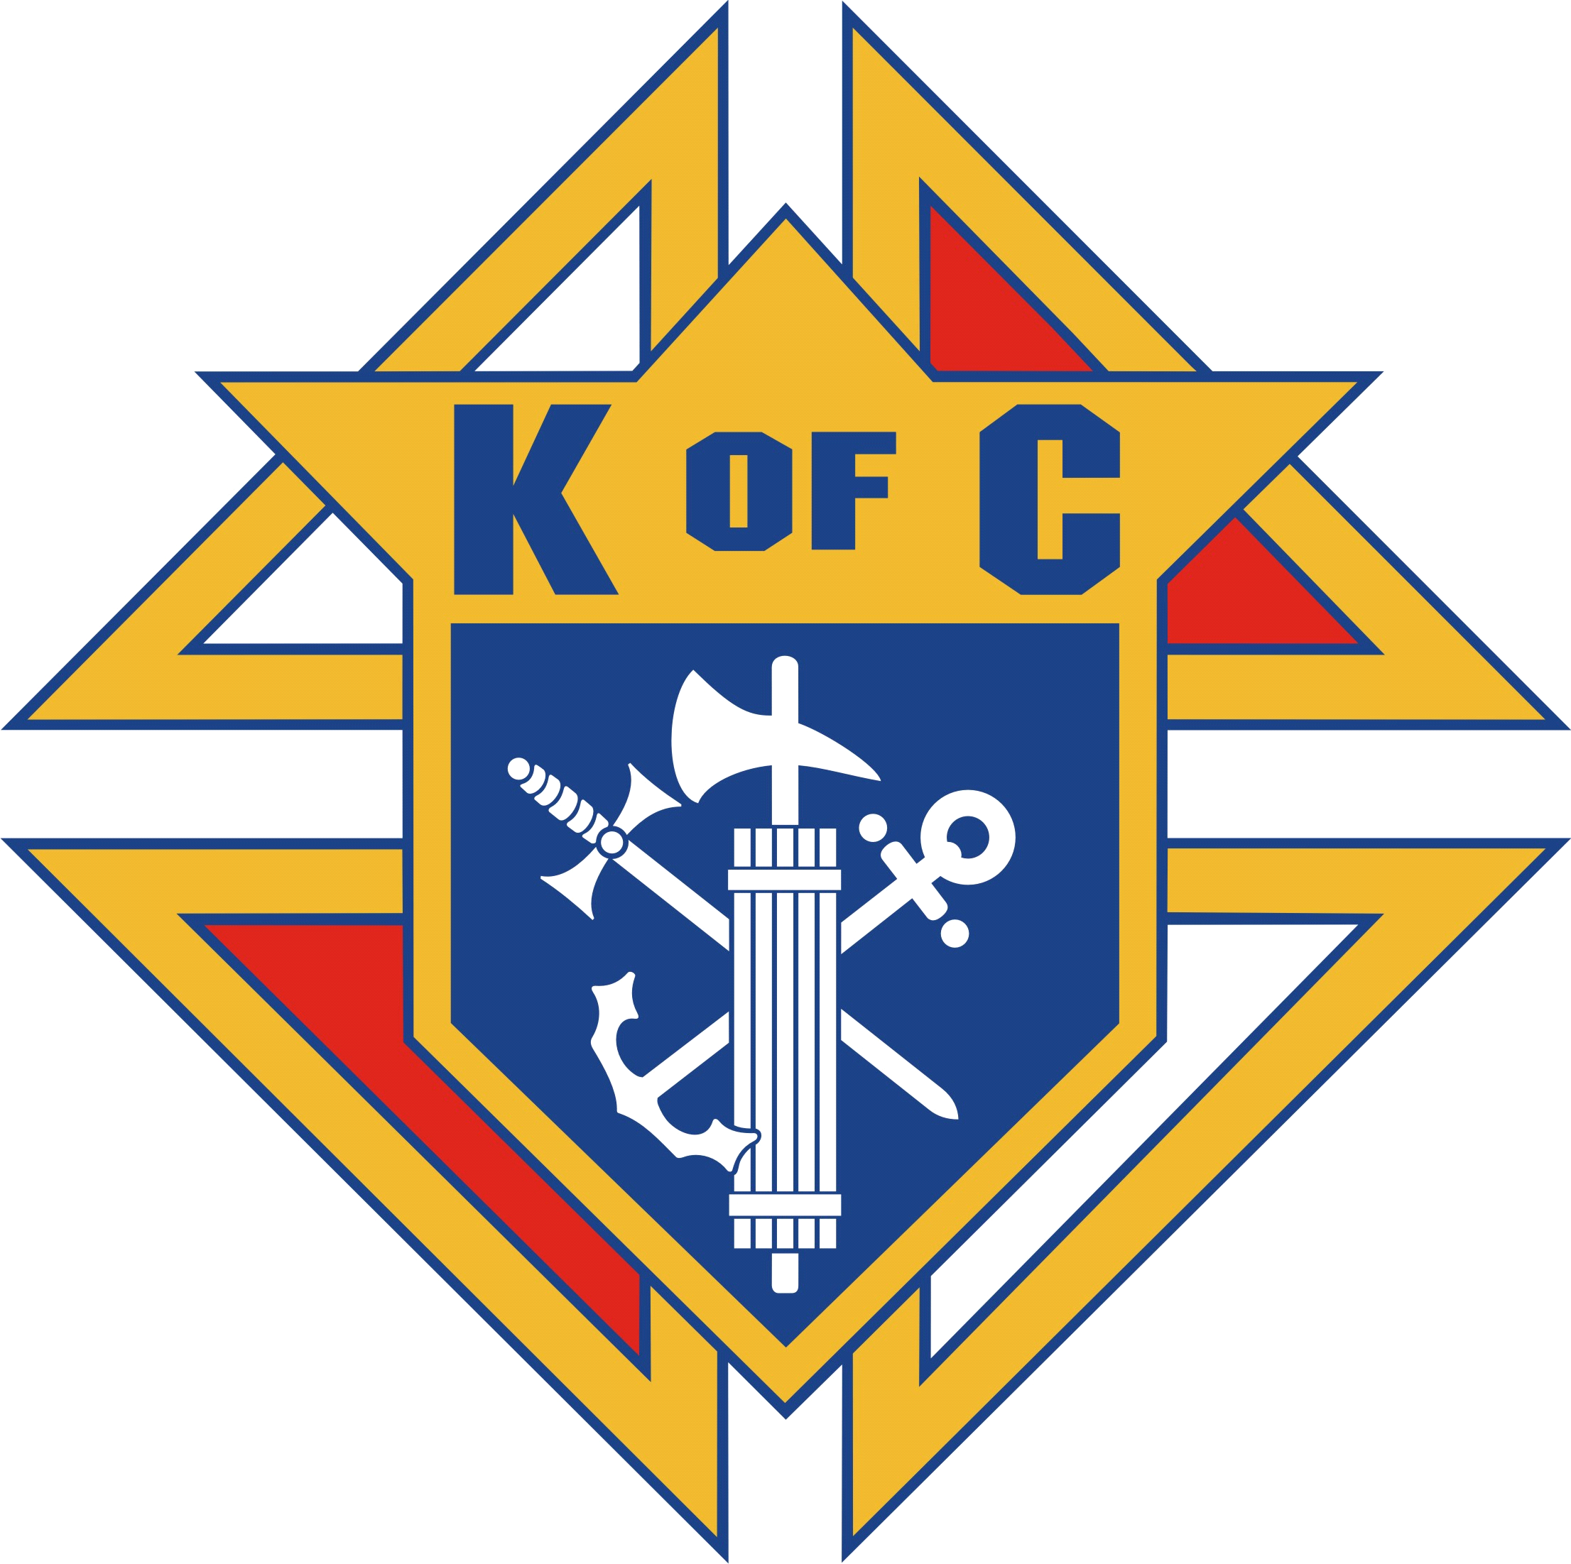Knights of Columbus
East Providence Council, No. 1528
3200 Pawtucket Avenue
East Providence, Rhode Island 02915

Q: What is the date and time for the 2018 ROVAC Saturday Collection Event?
A: Place: E. P. Council #1528 - 3200 Pawtucket Avenue; East Providence
Date: Saturday December 15th
Time: 10AM to 4PM (Publicity photo shoot at 4:30PM)
(Hot lunch will be available and our Sports Bar opens at Noon)
Q: Can my Council get publicity for participating in Operation ROVAC?
A: YES! Please bring in your donations any time after 10AM along with your Council banner. We will take a photo of you (ON YOUR CAMERA WITH YOUR COUNCIL BANNER) behind all of our donations. That photo along with a short press release (Simply fill in your name(s) and Council information) that will be emailed to you, will allow you to submit both to your local newspaper and generate wonderful publicity for your Council.
Q: What if I have donations for ROVAC, but I cannot get them to E.P. Council #1528 on December 16th?
A: No worries. Please call Big Blue Bug Solutions at (401) 941-5700 and explain that you have a donation for Operation ROVAC. Big Blue Bug Solutions will send one of their local Technicians to your address who will identify themselves and collect your donation. Your donation will be added to all the donations from across the state and delivered to the R.I. Veteran’s Home in time for Christmas.
Q: How can I assist the Operation ROVAC Collection Drive?
A: We would greatly appreciate any manpower to assist in the organization of the donations at any time between 10AM and 6PM on Saturday, December 15th. All of our collections will be bagged and boxed for shipment at the end of the day on the 16th. On December 16th, we will also greatly appreciate any manpower between 10AM and Noon as we pack the donations in our truck, drive them to Big Blue Solutions in Providence, and unload them.
Knights of Columbus
East Providence Council, No. 1528
3200 Pawtucket Avenue
East Providence, Rhode Island 02915

Operation ROVAC Timeline
- Late October:
- All Councils across the state should have this FAQ / Timeline sheet and the generic ROVAC flyers (Simply change to your Council name, address, and contact information)

- Absolutely No Later Than November 15th:
- All ROVAC collection boxes with your flyers attached should be posted in your Council chambers, Council halls, local Catholic schools, and/or Catholic churches

- Saturday, December 15th (At E. P. Council #1528):
- 10AM to 4PM – Drop off all donations at E. P. Council #1528
- Noon – Bar open / hot lunch available / sports on our multiple big screens all day
- 4:30PM – Major photo opportunity with all of our donations from across the state and our State Officers
- 5PM – Bag and box all of our donations for pickup on Sunday morning
- ALL DAY SATURDAY: Individual photos with each Council (Please bring your own camera and your Council banner) for submission to local print media. A short press release template will be emailed to you for local press submission (Along with the photo on your camera) for all Councils who participate.

- Sunday, December 16^{th:}
- 10AM to Noon - Truck picks up all of our donations at E. P Council and delivers them to the Big Blue Bug Solutions warehouse in Providence.

