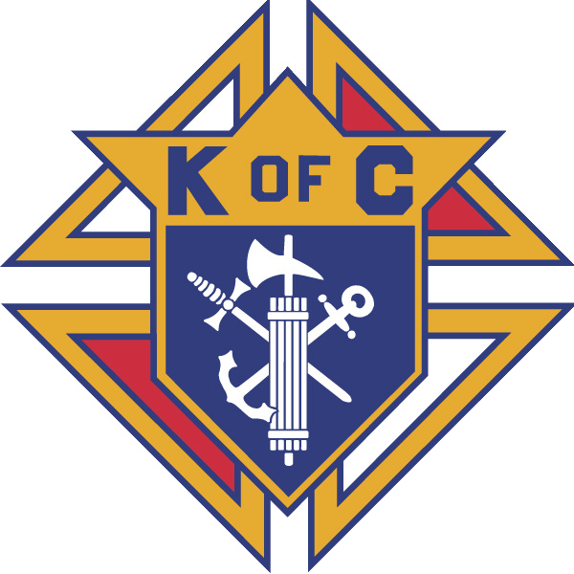

October 28, 2017
MAJOR DEGREE CEREMONY
New Braunfels
Knights of Columbus
Registration: 7:00 – 9:30 AM
Cost is $15.00 Includes lunch for candidates
Mass: 8:00 AM (Saints Peter & Paul Church)
Free Continental Breakfast
Major Degree: 10:00 AM
Lunch following the degree -- $7.00
RSVP BY October 25TH
111 Landa Street, New Braunfels, TX 78130
Contact GK Henry Hull
(K/C Hall) 830-632-5070 (H) 830-625-4615
hhull@satx.rr.com
D/D Joe Hernandez
830-832-6050
bmh1@satx.rr.com
Candidates need to bring their own medallions or medallions will be available for $6 .00

