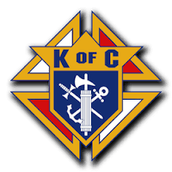
ST. MARY OF HUNTLEY July 2017 Issue
KNIGHTS OF COLUMBUS COUNCIL 11666 www.huntleyknights.org
KNIGHTS MONTHLY NEWS BULLETIN
UPCOMING FOR August, 2017:
08/01: Officers Meeting, starts at 7pm—Always open to all Brothers, bring your ideas!
08/05: Blood Drive- 7:30am-1:30pm, contact Bro. Bill Byrne; stmaryblooddrive@gmail.com
08/08: Monthly Rosary 6:15 pm in the church, come and pray with your Brothers.
Council Business Meeting, starts at 7pm – ALL MEMBERS
08/12: KC Academy at Holy Apostles Parish, Mc Henry, from 9:30am-1:30pm;
GK Phil Miller is the Event Chair; gk@huntleyknights.org
08/15: Ladies Auxiliary General Meeting, 7pm – ALL MEMBERS
08/22: 4th Degree Assembly Meeting, 7:30 pm at St. Margaret Mary, 111 S. Hubbard St
McDonnell Hall, Algonquin, IL
AUGUST: Knights Weekly Adoration Hour, Sunday Mornings@2am – 3am.
Team Leader—Jim Kalas→ 08/06—Jim Kalas;
08/13 Guy DeMaertelaere; 8/20—Sam Cory; 8/27-- Jim Kalas.
Want to sign up, too? https://www.volunteersignup.org/3A4HH

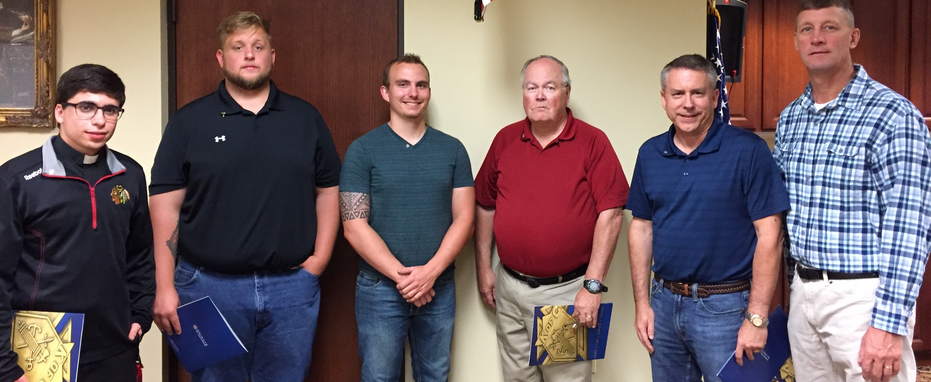
Welcome to our new Brother Knights who took the Admissions Degree Friday, July 14, 2017, from the left, Seminarian Miles Monaco, Jacob Mueller, Nathan Kalas,
Tom O’Shea, Jim Edkins and Kent Holub.

-Recruitment Weekend July 22 & 23; Brothers talked from the pulpit at the end of each Mass, inviting more men in our parish to join our council.

NOT A KNIGHT? WE INVITE YOU TO JOIN US! We are Catholic Men, Brothers in Christ, who want to serve our Lord, following our order’s principles of Charity, Unity, Fraternity and Patriotism. Please prayerfully consider--do you have a calling to become a Knight of Columbus? Becoming one of over 300 Brothers at St. Mary’s, serving the parish and participating in the many charitable activities we sponsor, you will find a great feeling in your heart and know you are part of a great group of guys who practice your Catholic values in family, community, and service to others each day. Stop in the Narthex and pickup an information pamphlet, or call; Deputy Grand Knight Dave Babicz at 847-530-1310
And now for the rest of the story!
Only via e-mail!!!!!!!!
--Our Budget--Your Officers worked diligently to put together a budget for the coming year and it was approved.

--09/08/17—A Friday afternoon golf outing, new for our council, hopes to increase participation by not conflicting with family stuff that normally occurs on weekends. Held at Turnberry Country Club and Co-Chaired by Brothers Rick Summerville and Damon Frugoli. Price this year is $115 for golf and dinner. Go to the calendar page on our website for contact info and more details. Plan your foursomes now! Shotgun start at 12:30pm!!!!! We will support the Blue Nuns in Freeport in their effort creating The Madonna Renewal Center, a Home of Renewal, Hope and Dignity for Women.

--Weekend of 09/15-16-17/08—ID Drive (aka: Tootsie Roll Drive). Chairman is Brother Ted Mellenthin. More to come; plan to help out if you can. Watch for sign up. Plan to bring your kids and/or grandkids, make it a family event!!!!! Get in the family calendar now, kids really feel good helping when they know more about whom and how they are helping.

--Pancake Breakfast Co-Chaired by Brother Jim Kalas and Brad Lauinger will be held sometime in September, date to be determined. Watch for more info. Join the crew for a shift and plan to have fun, too!

--12/02/17—Elgin Soup Kitchen Crew---Knights asked to crew the Elgin Soup Kitchen, 33:30pm-7:00pm. Chairman is Brother Brad Lauinger, more to come. He will need a minimum of 15 Brothers, so let him know soon if you want to participate.

And a final word…..
--If you have not looked at our council website, go there and wander a little, you will not be disappointed—huntleyknights.org Vivat Jesus!

