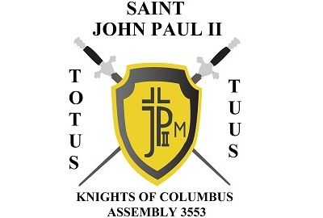
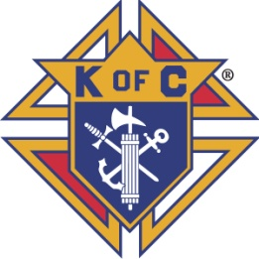
Saint John-Paul II Assembly 3553

September, 2020 Newsletter

Coronavirus
All officer meetings and Assembly meetings will be virtual through the end of the year. Please watch your e-mail for virtual meeting instructions.

SK Joe Collard
Please continue to pray for the repose of the soul of our dear departed Brother SK Joe Collard. The rosary is scheduled for Friday Oct 2 at 6:00PM, the funeral is scheduled for Saturday Oct 3 at 1:00PM. Please also keep the Collard family in your prayers during this difficult time. At our Oct 1 Officers meeting, it was approved that our 4th Degree Knight of the Year be renamed to honor SK Joe Collard.

Fall Exemplification
We will have 2 4th Degree candidates for the October 10th Exemplification at Council 5052 KofC Hall in Farmers Branch. Due to COVID restrictions, our new member social is on hold until restrictions ease or we come up with an alternative.

Facemask Fundraiser
We took orders for over 200 facemasks for our fundraiser. Masks will be distributed after Masses the weekend of Oct 3/Oct 4.

Please pray for all those affected by the coronavirus outbreak, including the victims, the family members, the medical staffs, the first responders, and all those who are working to help us through this.

Totus Tuus,

SK John Stemniski, Faithful Navigator

