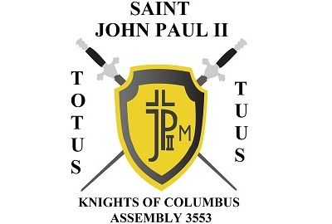
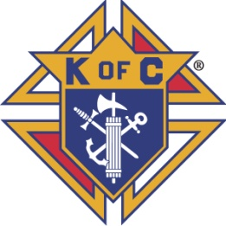
Saint John-Paul II Assembly 3553

December, 2022 Newsletter

Wreaths Across America
Thank you to all who participated in Wreaths Across America at Pecan Grove and Allen Cemetery. Weather is no deterrent, as we will always show our respect to our Veterans who have passed.

Christmas Cards for the Deployed
Thank you to all who sent Christmas cards to those currently deployed in the units under Sir Knight and Brigadier General Mike Yost. Thank you SK Mike for recommending this! This is a great example of what our Assembly stands for.

Epiphany Social
Our next social event will be our Epiphany Social sometime in early January 2023, likely January 7 after the 5:00 Mass. Stay tuned for email and other communication regarding this event, once the details are known.

Upcoming Meeting Schedule
After the holiday periods in November and December, our normal meeting schedule will resume in January. The next Assembly meeting will be Jan 26, 2023. The Officers Meeting will take place on Jan 5, 2023.

Happy New Year to All
I would like to wish all Sir Knights and their family a blessed and prosperous New Year 2023.

Totus Tuus,
SK John Stemniski, Faithful Navigator

